**编 号**

**上海体育学院本科毕业设计**

**（2018 届）**

|  |  |
| --- | --- |
| **毕业设计题目：** | **《健身气功·八段锦》翻译** |
| **综述报告题目：** | **《健身气功·八段锦》翻译报告** |
| **作 者：** | **陈丹琪** |
| **指 导 教 师：** | **陈 珊** |
| **所 属 系 院：** | **体育新闻传播与外语学院** |
| **毕 业 专 业：** | **英语专业** |
| **学 号：** | **14520124** |

**The Translation of *Gymnastic Qigong·Eight-Section Brocade***

**by**

**Danqi Chen**

**A Thesis**

**Submitted to the Department of Foreign Languages**

**in Partial Fulfillment of the Requirements for**

**the Degree of Bachelor of Arts**

**Under the Supervision of Shan Chen**

**Shanghai University of Sport**

**May 2018**

**目录**

摘要 3

Abstract 3

健身气功·八段锦翻译报告 3

参考文献 3

中文原文 5

第一节 功法源流 5

第二节 功法特点 5

第三节 动作说明 5

手型、步型 5

动作图解 5

预备势 5

第一式 两手托天理三焦 5

第二式 左右开弓似射雕 5

第三式 调理脾胃须单举 5

第四式 五劳七伤往后瞧 5

第五式 摇头摆尾去心火 5

第六式 两手攀足固肾腰 5

第七式 攒拳怒目增气力 5

致谢 5

八段锦专有动作表（中英文对照） 6

英文译文 6

Chapter One Source of Method 6

Chapter Two Feature of Method 6

Chapter Three Movement Description 6

Hand, stance 6

Movement diagram 6

Preparing form 6

First Form Hold the hands high with palms upward to regulate three Jiao 6

Second Form Bow from left to right as shooting the condor 6

Third Form Regulate spleen and stomach with one palm lifted up 6

Fourth Form Sickness, stress and diseases, throw them away 6

Fifth Form Swing the head and lower the body to relive Xin Huo (Yang diseases) 6

Sixth Form Bend with Two hands put on feet good for kidneys & waist 6

Seventh Form Clench fists for powerful strength 6

Acknowledgement 6

**摘 要**

众所周知，我国体育文化正在逐步与世界接轨——中华传统武术俨然已经走出国门，走进世界，成为大家共同的运动财富和养身财富。武术中的健身气功八段锦，作为中华养生文化中的瑰宝，无疑是中华体育文化的精髓。加强其对外传播是提升中国文化“软实力”的重要途径。

在不断推进和完善我国武术文化对外传播的过程中，翻译无疑占据着举足轻重的地位。翻译材料是对外传播的信息载体，翻译的品质直接影响对外宣传的效果。武术文化的翻译不是单纯的语言转码，而是体育文化内涵的对外移植。意义明确、用语规范、语言科学简洁的术语是任何先进文化传播与前进的基础。尤其在武术运动对外传播时，术语表达的规范化及翻译工作的准确性是彼此沟通的基础，更是全球体育文化交流过程中体育运动对其自身提出的严格要求。因此，八段锦的翻译不仅要注意语言技巧层面，更要关注中西文化差异，秉承文化翻译观，灵活地采用适当的翻译方法，兼顾实现信息传递和保留文化特色的双重目的，这样才能达到最大化的弘扬与宣传力度。

鉴于现行八段锦教材的英译版本较少，其翻译策略方法未形成体系，对气功的内涵认识也不够准确和深入。因此，本文以相应的翻译理论为基础，从国际化、标准化的角度对八段锦进行翻译，希望能为八段锦的国际传播添砖加瓦。

**关键词：气功文化；八段锦；翻译；文化传播**

**Abstract**

As is known to all, China's sports culture is becoming increasingly connected with the world——the traditional Chinese martial arts have gone out of China into the world, which become the common sports wealth and health wealth.Gymnastic Qigong·Eight-Section Brocade in the martial arts, as the treasure of Chinese health culture, is undoubtedly the essence of Chinese sports culture. Strengthening its external communication is an important way to enhance the "soft power" of Chinese culture.

In the process of constantly promoting and perfecting the foreign communication of Chinese martial arts culture, translation undoubtedly plays an important role. Translation material is the information carrier of external communication, and the quality of translation directly influences the effect of external publicity. The translation of martial arts culture is not merely the transcoding of language, but the external transplantation of sports culture connotation. The terms of clear meaning, normative language and simple language science are the basis of any advanced culture communication and advance. Especially in external communication of martial arts sports, both standardization of the terms and accuracy of the translation are the foundation of communication with each other, what’s more, which are strict requirements offered on their own in the process of the global sports cultural communication. Therefore, attention in translation of Eight-Section Brocade should not only paid to language skills level, but also more attention to differences between Chinese and western culture, adhering to the concept of cultural translation, using appropriate translation methods flexibly, achieving information transmission and preserving cultural characteristics of dual purpose so as to maximize the promotion and propaganda.

In view of the fact that there are few current English translation versions ofEight-Section Brocade, whose translation strategy and method have not formed a system yet and connotation of Qigong is not accurate and thorough. Therefore, this thesis translates Eight-Section Brocade from the perspective of internationalization and standardization based on the corresponding translation theory, hoping to contribute to the international spread of the Eight-Section Brocade.

**Key Words：Qigong Culture, Eight-Section Brocade, Translation, Cultural Spread**

**健身气功·八段锦翻译报告**

1. 翻译任务描述

1.1翻译背景介绍

武术英译源于1 9 世纪初期旅居海外的华人习武者，他们从理论和实践等方面对中国武术诸流派、阴阳哲理、武术基础训练等方面做出了详尽的介绍，使中华武术在海外得以更广泛的传播。外文出版社翻译并出版了数余部武术系列丛书。

中华武术文化有着极其丰富的内容，历史悠久，自成体系；它以自己的体育文化方式发展、传承，是人类体育文化的杰出代表之一。它蕴涵中华文化精髓，弘扬中华民族精神，是中华民族宝贵的文化遗产。随着全球化的进程，国际体育文化交流和融合已成为必然趋势。挖掘和传承我武术文化，进一步推向世界，是提升我国国际体育文化影响力、丰富我国国际文化形象的重要举措。武术中的健身气功——八段锦，作为中华民族的优秀文化遗产之一，无疑是中华体育文化的精髓。将其进行精准的翻译并对外进行宣传是传播武术文化、增强武术文化国际影响力的重要途径。因此，本文以相应的翻译理论为基础，从国际化、标准化的角度对八段锦进行翻译。

1.2材料来源

健身气功——社会体育指导员培训教材

1.3作者简介

国家体育总局健身气功管理中心

一、全面负责健身气功的业务管理，研究和制定健身气功的方针、政策、发展规划和管理制度，积极开展宣传工作；

二、审核、推广科学健康的健身气功方法；

三、制定健身气功辅导人员的管理制度，负责健身气功辅导人员的业务培训；

四、组织健身气功的科学研究；

五、对全国性健身气功活动进行业务管理，指导地方健身气功业务工作；

六、负责健身气功对外交流工作，负责在我国举办的国际健身气功活动的审批和组织工作；

七、协调组织人体科学研究；

八、负责中国健身气功协会的日常工作，广泛联系和团结社会各界人士，充分发挥协会的桥梁和纽带作用；

九、完成总局交办的其他工作

1.4 作品简介

本作品分为上、下两篇。上篇为健身气功基本理论，下篇为国家体育总局组织编创的四种健身气功。

本作品是在充分吸纳《健身气功培训教程（试用）》和体育院校相关教材内容及运用大量文献资料的基础上完成的。在编写过程中，我们做了以下几个方面的努力。一是注重把握教材的针对性，紧紧围绕以培训健身气功项目各级社会体育指导员为主体而设置教材框架和内容；二是注重把握教材的科学性，充分体现先进的健身气功理论成果，努力剔除不科学的观点，力争不引用尚有争议的资料，尽量做到概念阐述准确，论据充分可靠；三是注重教材的实用性，充分考虑教学的受众面，力求深入浅出、通俗易懂，既可作为培训健身气功的教材，亦可作为练功群众的科普读物。

2. 翻译过程综述

2.1 译前准备

1.首先通读《健身气功·八段锦》的原文，大致了解其内容主旨

2.精读原文，同时研究和分析八段锦这项健身气功所包含的功法源流、功法特点、习练要领以及动作分解

3.观看欣赏八段锦的精彩表演视频，再切身体验八段锦的练法精髓

4.查阅健身气功的相关翻译文献，研究并掌握所要运用的翻译理论：功能目的论

5.大致翻译出全文，形成初稿，将其中的翻译重点和难点提炼出来，反复推敲、斟酌

2.1.1 原文阅读与分析

原文分为三节：八段锦的功法源流、功法特点、动作分解。第一节功法源流精炼地介绍了八段锦的历史来源和其中所蕴含的文化内涵，并且八段锦有坐势和立势之分，还谈及流传过程中出现的著名流派。第二节功法特点分为三部分讲解了其特殊性以及重要性，强调了“健身气功·八段锦”的运动强度和动作的编排次序符合运动学和生理学规律，属于有氧运动，有利于健身养生。第三节动作分解分为十个部分：预备势、动作八式、收势，整套功法以最初的八式为基础，增加了预备势和收势，使八段锦的套路更加完整规范。每一式不仅有详细的细节描述，还包括动作要点、易犯错误、纠正方法和功理作用，简洁易懂，易于掌握。这些都是本文翻译过程应当注意的重难点。

2.1.2翻译技巧和翻译理论的选择

本文运用文献资料法与逻辑分析法，对健身气功八段锦这一中华武术项目的历史起源，文化内涵，技术要领等方面进行较为深入的阐述。

体育英语翻译属于实用性翻译的范畴，实用性翻译强调翻译文本完成指定功能的准确性。观翻译史，德国功能主义理论素以重视翻译目的为主要特色和标准。根据德国功能派翻译学者费米尔和诺德等提出的翻译理论“目的论Skopos Theory”，所有翻译要遵循的首要法则就是“目的法则”，翻译目的论注重的不是译文与原文是否对等或译文是否完美，而是强调译文应该在分析原文的基础上，以译文预期功能为目的，选择 最佳处理方法。目的论学者提出的翻译过程三大法则的标准，即“目的法则(skopos rule)”、“连贯法则(coherence rule)”、“语内连贯(intratextual coherence)”的标准。功能目的论为不符合传统翻译标准的翻译方法提供了有力的理论支持。功能目的论为翻译研究提供了新的视角，它尤其适用于传统体育项目这种有明确功能的文本翻译。

功能目的论作为德国功能主义的代表性理论是强调翻译标准多元化的理论体系。功能目的理论为不符合传统翻译标准的翻译方法提供了有力的理论支持。功能目的论为翻译研究提供了新的视角，它尤其适用于体育英语这种有明确功能的文本翻译。

因此，本文翻译以功能目的论为理论依据，从宏观视角出发，以译文为中心，强调了八段锦的目的性，突出译文在译语文化环境中所预期达到的功能。

方法是指人们为获得某种东西或达到某种目的而采取的手段与行为方式。顾名思义，传统体育项目的术语翻译方法就是将源语言转换成目的语国家语言时所采取的手段与行为方式。因此本文采用了形式多样的翻译方法以及多种方法结合使用，共采用5种翻译技巧：音译法、直译+解释法、意译法、注释法、归化法和异化法并用。

原则就像一个标杆，在构建译文体系时起着指导性的作用，它是保证译文始终围绕一个中心或主题进行的统领性标尺。本文采用了以下6种翻译原则：

1.专业化原则：术语学是研究术语规律的科学，是指导术语规范与统一工作的理论，专门探讨多学科术语的概念、概念分类、术语命名的原则、演变以及规范等。专业性是术语的最根本特征。传统体育项目术语则是该领域的专门用途语言，具有较强的专业性。因此，应尽量把武术术语原语吃透，不是单纯顾及表面之意，而是探究其原文意图和挖掘出其深层的涵义以及其弦外音等，体现出较强的专业性，避免原语的信息缺失，以便读者能接受。

2.民族化原则：任何一种语言都是在历史的长河中逐渐形成的，都富有民族性、历史性和文化内涵。文化的传播依赖于语言，民族文化在术语层次上更加突出，其中传统体育项目术语就是典型范例。许多体育术语的命名都来自国学文化的移植。应对此类体育术语进行翻译时，选取合适的翻译方法与技巧，即忠实于原术语的本意意图，又凸显民族特色的问题不容忽视。因此，翻译过程中会着重考虑到这一方面的因素，使翻译更加民族化。

3.科学性原则：只有遵循这个原则，翻译过程才能顺利进行，英译工作才会达到事半功倍的效果。译文体系的建设若不科学，违反科学性原则，那么其结果必定会阻碍我国气功文化的对外传播和弘扬。因此本文翻译坚持遵循科学性原则，使专业术语，词汇、句法、语篇表达等都尽量科学合理，通顺流畅。

4.系统性原则：标准化体系是指一定范围内的标准按其内在联系形成的科学的有机整体。译文应该能够科学全面地反映原文所包含的内容并尽可能多维立体地将其展现出来，全面成套并且层次恰当，子体系和子子体系之间划分清晰。尤其是健身气功翻译中涉及到许多人体部位，器官结构，如果不全面则体系就不再称为体系，更谈不上标准化。但是全面并不是要求体系构建时内容重复而冗杂，甚至含糊不清，而是能够清晰地说明体系所包含的内容，让人一目了然，不赘述，不重叠。体系要具有整体上的统领性和很强的系统性，面面俱到而不事无巨细。

5.可接受性原则：英译时需要考虑体系的适用对象，必须使体系内部和外部适用对象理解，也就是说以汉语为母语的人和以英语为母语的人都能接受。考虑两种文化的差异，做到构建的武术英译标准化体系指导下的武术英译工作既忠实于本土文化，又和国际上武术文化的接受者的文化相融。同时对不同类型的武术英译标准化进行区分处理，而不是一概而论，搞“一刀切”工作。如在武术英译工作中对武术术语进行英译时要“以类聚”。

6.导向性原则：因为健身气功本身承载的就是一种东方文化，武术英译过程其实就是文化的交流过程，既然是交流，那么它就是一个双向的活动，是一个相互影响的过程。文化在相互影响时就是本土化和国际化的问题，也就是说气功文化在国际传播中有可能真真正正地切实传播中国的文化，也有可能被其他文化所同化，所以翻译过程中一定要有导向性，有一个系统有序的文化方向。

最后，基于八段锦的文化理念和蕴含的健身之道和气功精神的感悟和体会，从国际化、标准化的角度将八段锦的翻译更好地呈现给读者。

2.2 初译稿修改中的难点

初译稿修改过程中的难点主要集中在词汇、句法、篇章三个方面方面。

词汇方面：针对八段锦中的许多专业术语，在查阅相关健身气功术语翻译的文献资料后，将反复出现的名词及名词词组经过语料库网站多次反复搜索确认之后，最终以一份专业术语表的形式呈现出译文成果。不仅如此，翻译其他词汇时也字字斟酌、反复推敲，注重词义的精确表达。尤其是一些包含中华传统元素的词汇，绝大多数是四字格，意义相通，甚至押韵，表述的内容极为抽象，正如汉语文章那样形散神不散，而目的语的英文则是一门具体的语言，这就需要在两者之间找到共通之处进行翻译桥梁的架接，既能表达中文含义，又能在英语中找到平衡，以西方思维和表达方式重现中华文化的妙处，对双方文化的掌握以及语言凝练的要求很高。

句法方面：源语言是汉语，重内容，多短句，表达呈树冠式，而目的语是英语，其语言特点重形式、多长句，表达呈竹节式，原材料中也大量呈现了汉语总体抽象性的特点，为了更好地进行翻译工作，就需要对汉英两种语言有一定程度的掌握，并且在汉英之间进行无缝巧妙的转换，尽量还原出英语句式复杂多变的特点。因此，应着重关注中英语序的调整、句子成分的分析以及语言组织方面的修正。

篇章方面：初译稿时，尽管通读精读了全文，但对文章的写作思路把握不到位、语言风格和结构框架也理解不全面，因此句子的流畅性和连贯性欠妥，导致语句之间、语段之间、语篇之间衔接性不足，语义表达一致性欠缺。因此，审读过程中注重将原文和译文每句进行对比，修改、校对错译漏译处，同时保证译文的准确性和流畅性。

2.3 审读、润色和定稿

首先，大致掌握文章概况和语言表达，通译全文。

其次，认真审读数遍后，将译文的硬译、错译、漏译之处加以订正，尤其是一词多译、多词一译以及硬译、错译等常见现象，应加以注意，通过修改句式或者换用词性的方法再次精准翻译，以提高读者可读性，达到润色的效果。

最后，略读和精读双管齐下，将译文交由导师审阅后，形成终稿。

3. 翻译案例分析

3.1 词汇分析

3.1.1词义的选择

例1：

译语中可以找到的原语对应词汇“手、脾、胃、头、足、肾、拳、目”就直译成“hands、spleen、stomach、head、feet、kidneys、fits、eyes”,“理（调理）、瞧、去、固、增”直译成“regulate、look、relieve、strengthen、enhance”,“左右、往后”直译成“left and right、backwards”等，这些都是术语词汇意义的对等。考虑到许多外国读者对中华健身气功——养生文化的生疏，“三焦”如果译成“internal organs”代替音译的“Three Jiao”,表达虽简洁却比较模糊，无法体现出“上焦、中焦、下焦”的具体中医内涵，因此翻译过程中，本文采用音译加注释的方法来诠释这个术语：Three Jiao（Shang Jiao: heart and lungs, Zhong Jiao: spleen and stomach, Xia Jiao: liver and kidneys）。

再如，“动作”一词的翻译，初译稿中将其译文“action”，但“action”的含义是the process of doing something in order to make something happen or to deal with a situation，而“move”的含义为to change position or make somebody/something change position in a way that can be seen, heard or felt. 因此，在审读以及后期修改过程中，在查阅大量相关健身气功的文献资料后，将其改译为“move”，词汇的精确性得到了较好的诠释。

3.1.1增词和减词

例2增词：

练习八段锦中时常出现的一个动作“约与肩同宽” ，如果直译就是“about the same width as the shoulders”这样一来，主语成分模糊、意义表达极不明确，让外国读者不知所云，一头雾水，无疑犯了死译、硬译的错误，因此应将主语补充完整，适当地进行调整，改译为“the distance of feet is the same as shoulders”实际上，“约与肩同宽”表达的就是两脚之间的距离与肩膀的宽度大致相同，翻译过程中，“宽”一词显然不需要，“shoulders”显然暗含了宽度的含义，只需要增添“the distance of feet”即可。

例3减词：

健身气功成为“传播中华优秀传统文化的新使者，宣传中华民族传统体育项目的新亮点”一句“a new messenger of the fine traditional Chinese culture and a new light to promote the traditional Chinese sport”，是非常典型的为了表达句子的平衡对称，达到声韵和美的中文句子。“新使者”和“新亮点”实际上表达的是同一个意思，即“新的途径”或“新的手段”。如果按中文表达照直翻译，选择用messenger和light两词根本没有表达出原文的内涵。同时，“新使者”和“新亮点”如果都翻译为英语，将出现不必要的赘词，因此，只翻译其中一个词即可。

例4减词：

“手型、步型”两个词汇的翻译，如果按原文直译就是“hand type”和“stance type”，然而经过推敲和斟酌，最终改译为“hand”和“stance”就是遵循了翻译中的经济性原则——适当的减词和省词，已达到词义表达精准，不冗余不累赘的效果，使译文简洁有力，通顺流畅。

3.2 句法分析

例5：

在语义、风格和文体上的对等翻译也有体现，比如，句中非谓语动词“to do”的使用能很好地表达出健身气功“八段锦”动作所具有的功法功效目的。另外，“八段锦”其文已被歌诀化，在英译时形成排比句式有助于再现其歌诀文体，但是用动名词“doing”的形式在句首指导气功的各项功法动作在语法上有些牵强，不如直接使用动词原形的祈使句更好。

* 1. 语篇分析

例6：

例如，落地震动可轻度刺激下肢及脊柱各关节内外结构，并使全身肌肉得到放松复位，有助于解除肌肉紧张译为“The vibration when two heels fall to the ground can mildly stimulate the internal and external structures of the lower limbs and the spine, and relax the muscles in the whole body, which can help to relieve muscle tension.” 整句话虽长，但思路清晰、井井有条，两个并列分句无疑精炼地阐述了这一动作所带来的功理与作用，这两项功效地位平等，同等重要，最后一句用“which”来引导一个非限定性谓语，有统领全局和总结点睛的效果。

4. 翻译实践总结

本文认为健身气功文化的英译在方法选择上需要注意以下内容：第一，要认清气功中所蕴涵的文化内涵，在翻译中结合不同的英译法予以准确表达；第二，考虑翻译对外宣传目的，合理使用各种英译法扩大气功文化在海外的现有影响力；第三，要结合具体语境，选择并且优化使用英译方法，灵活对等再现原文风貌。为此，要先将原文本读懂并深刻理解其文化内涵，知晓国外对该气功文化——八段锦的现有了解情况，有意识地照顾到外国友人的理解和接受能力，在具体语境下仔细斟酌选词用句，恰当地选择最合适的英译法。

中国传统体育对外宣传翻译强调的就是译文功能，即让更多的国家了解中国的传统体育。 因此，在中国传统体育对外宣传翻译中遵照skopos翻译原则，有助于表达原文意图和达到对外宣传的目的。Skopos翻译原则为中国传统体育对外宣传翻译工作者提供了可遵循的原则，不仅如此，译者必须以扎实的语言功底和娴熟的翻译技巧，严格的治学态度和良好的职业道德，做到内知国情、外知世界，特别要了解中国的对外政策和外国人对中国体育文化的理解能力。充分考虑文化差异，努力跨越文化鸿沟，避免亦步亦趋，实现中国传统体育对外宣传的交际功能，达到中国传统体育对外宣传翻译的最终目的，以中国体育文化为取向，以 中国传统体育对外宣传译文为重点，为中国传统体育的发展和中西体育文化的交流添砖加瓦。

5.参考文献

[1]高濂. 遵生八笺[M].国家图书馆馆藏本

[2]洪迈. 夷坚志[M]. 国家图书馆馆藏本

[3]金惠康．跨文化交际翻译续编[M]．北京：中国对外翻译出版公司，2004：59．70．

[4]杨梅. 中国传统体育对外宣传翻译的原则——以中国健身气功对外宣传册的英文翻译为例[J].武汉体育学院学报,2007(05):20-23.

[5] 佘丹,陈南生.归化异化策略在武术中术语翻译的应用及评析[J].西安体育学院学报,2007,24(6):58-60.

[6]王海丽.试论目的论视角下的中华传统武术术语翻译[D].山西大学,2008.

[7] 曲建梅.武术术语翻译策略研究[D].苏州大学,2008.

[8]李欣. 功能目的论指导下的体育英语翻译[D].哈尔滨工业大学,2009.

[9]段红萍. 社会传播学视角下的武术翻译[J]. 外国语文,2011,(01):112-115.

[10]刘明,刘占辉,王晓娟. 武术英语翻译的现状及策略研究[J]. 哈尔滨职业技术学院学报,2013,(02):109-110.

[11]艾春娇.全球化背景下武术术语翻译研究[D].华中师范大学,2014.

[12]张艳华. 武术英译标准化体系的构建研究[D].武汉体育学院,2015.

[13]张杰,刘英辉,李科. 我国传统体育项目对外宣传及其翻译的文化视域[J]. 山东体育学院学报,2015,(02):114-118.

[14] 张森,季蕊.中国传统武术术语英译的问题与对策探究[J].当代外语研究,2016,(4):67-70,87.

[15] Joan Pinkham．The Translator’s Guide to Chinglish[M]．北京：外语教学与研究出版社，2000：1-4．

健身气功·八段锦

1. 功法源流

八段锦的“八”字，不是单指段、节和八个动作，而是表示其功法有多种要素，相互制约，相互联系，循环运转。正如明朝高濂在其所著《遵生八笺》中“八段锦导引法”所讲：“子后午前做，造化合乾坤。循环次第转，八卦是良因。”“锦”字，是由“金”“帛”组成，以表示其精美华贵。除此之外，“锦”字还可理解为单个导引术式的汇集，如丝锦那样连绵不断，是一套完整的健身方法。

八段锦之名，最早出现在南宋洪迈所著《夷坚志》中：“政和七年，李似矩为起居郎……尝以夜半时起坐，嘘吸按摩，行所谓八段锦者。”说明八段锦在北宋已流传于世，并有坐势和立势之分。由于立势八段锦更便于群众习练，流传甚广。“健身气功·八段锦”以立势八段锦为蓝本，进行挖掘整理和编创。立势八段锦在养生文献上首见于南宋曾慥著《道枢·众妙篇》。总的来看，八段锦被分为南北两派。行功时动作柔和，多采用站式动作的，被称为南派，伪托梁世昌所传；动作多马步，以刚为主的，被称为北派，附会为岳飞所传。从文献和动作上考察，不论是南派还是北派，都同出一源。其中附会的传人无文字可考证。

新中国成立后，党和政府对民族传统体育项目非常重视。20世纪50年代后期，人民体育出版社先后出版了唐豪、马凤阁等人编著的《八段锦》，后又组织编写小组对传统八段锦进行了挖掘整理。由于政府的重视，习练八段锦的群众逐年增多。到20世纪70年代末80年代初，八段锦作为民族传统体育项目开始进入我国大专院校课程。这些都极大地促进了八段锦理论的发展，丰富了八段锦的内涵。

通过对大量文献史料的查阅、考证，有以下基本认识：

1. 传统八段锦流传年代应早于宋代，在明清时期有了较大发展。

2. 传统八段锦创编人尚无定论，可以说八段锦是历代养生家和习练者共同创造的知识财富。

3. 清末以前的八段锦主要是一种以肢体运动为主的导引术。

4. 八段锦无论是南派、北派或是文武不同练法，都同出一源，在流传中相互渗透，逐渐趋向一致。

第二节 功法特点

“健身气功·八段锦”的运动强度和动作的编排次序符合运动学和生理学规律，属于有氧运动，安全可靠。整套功法增加了预备势和收势，使套路更加完整规范。功法动作特点主要体现在以下几个方面。

一．柔和缓慢，圆活连贯

柔和，是指习练时动作不僵不拘，轻松自如，舒展大方。缓慢，是指习练时身体重心平稳。圆活，是指动作路线带有弧形，不起棱角，不直来直往，符合人体各关节自然弯曲的状态。它是以腰脊为轴带动四肢运动，上下相随，节节贯穿。连贯，是要求动作的虚实变化和姿势的转换衔接，无停顿断续之处。既像行云流水连绵不断，又如春蚕吐丝相连无间，使人神清气爽，体态安详，从而达到疏通经络、畅通气血和强身健体的效果。

二．松紧结合，动静相兼

松，是指习练时肌肉、关节以及中枢神经系统、内脏器官的放松。在意识的主动支配下，逐步达到呼吸柔和、心静体松，同时松而不懈，保持正确的姿态，并将这种放松程度不断加深。紧，是指习练中适当用力，且缓慢进行，主要体现在前一动作的结束与下一动作的开始之前。八段锦中的“双手托天理三焦”的上托、“左右弯弓似射雕”的马步拉弓、“调理脾胃须单举”的上举、“五劳七伤往后瞧”的转头旋臂、“攒拳怒目增气力”的冲拳与抓握、“背后七颠百病消”的脚趾抓地与提肛等，都体现了这一点。紧，在动作中只在一瞬间，而放松须贯穿动作的始终。松紧配合得适度，有助于平衡阴阳、疏通经络、滑利关节、活血化淤、强筋壮骨、增强体质。

本功法中的动与静主要是指身体动作的外在表现。动，就是在意念的引导下，动作轻灵活泼、节节贯穿、舒适自然。静，是指在动作的节分处做到沉稳，特别是在前面所讲八个动作的缓慢用力之处，在外观上看略有停顿之感，但内劲没有停，肌肉继续用力，保持牵引抻拉。适当的用力和延长作用时间，能够使相应的部位受到一定的强度刺激，有助于提高锻炼效果。

三．神与形合，气寓其中

神，是指人体的精神状态和正常的意识活动，以及在意识支配下的形体表现。“神为形之主，形乃神之宅”。神与形是相互联系、相互促进的整体。本功法每势动作以及动作之间充满了对称与和谐，体现出内实精神、外示安逸，虚实相生、刚柔相济，做到了意动形随、神形兼备。气寓其中，是指通过精神的修养和形体的锻炼，促进真气在体内的运行，以达到强身健体的功效。习练本功法时，呼吸应顺畅，不可强吸硬呼。

第三节 动作说明

1. 手型、步型
2. 基本手型

**拳**

大拇指抵掐无名指根节内侧，其余四指屈拢收于掌心

**掌**

掌一：五指微屈，稍分开，掌心微含

掌二：拇指与食指竖直分开成八字状，其余三指第一、二指节屈收，掌心微含

**爪**

五指并拢，大拇指第一指节，其余四指第一、二指节屈收扣紧，手腕伸直

1. 基本步型

马步

开步站立，两脚间距约为本人脚长的2~3倍，屈膝半蹲，大腿略高于水平

二．动作图解

**预备势**

动作一：两脚并步站立；两臂自然垂于体侧；身体中正，目视前方

动作二：随着松腰沉髋，身体重心移至右腿；左脚向左侧开步，脚尖朝前，约与肩同宽；目视前方

动作三：两臂内旋，两掌分别向两侧摆起，约与髋同高，掌心向后；目视前方

动作四：上动不停。两腿膝关节稍屈；同时，两臂外旋，向前合抱于腹前呈圆弧形，与脐同高，掌心向内，两掌指间距约10厘米；目视前方

动作要点:

1. 头向上顶，下颏微收，舌抵上颚，双唇轻闭；沉肩坠肘，腋下虚掩；胸部宽舒，腹部松沉；收髋敛臀，上体中正
2. 呼吸徐缓，气沉丹田，调息6~9次

易犯错误

1. 抱球时，大拇指上翘，其余四指斜向地面
2. 塌腰，跪腿，八字脚

纠正方法

1. 沉肩，垂肘，指尖相对，大拇指放平
2. 收髋敛臀，命门穴放松；膝关节不超越脚尖，两脚平行站立

功理与作用

宁静心神，调整呼吸，内安五脏，端正身形，从精神与肢体上做好练功前的准备

**第一式 两手托天理三焦**

动作一：两臂外旋微下落，两掌五指分开在腹前交叉，掌心向上；目视前方

动作二：上动不停。两腿徐缓挺膝伸直；同时，两掌上托至胸前，随之两臂内旋向上托起，掌心向上；抬头，目视两掌

动作三：上动不停。两臂继续上托，肘关节伸直；同时，下颏内收，动作略停；目视前方

动作四：身体重心缓缓下降；两腿膝关节微屈；同时，十指慢慢分开，两臂分别向身体两侧下落，两掌捧于腹前，掌心向上；目视前方

本式托举、下落为1遍，共做6遍

**动作要点**

1. 两掌上托要舒胸展体，略有停顿，保持抻拉

2. 两掌下落，松腰沉髋，沉肩坠肘，松腕舒指，上体中正

易犯错误

两掌上托时，抬头不够，继续上举时松懈断劲

纠正方法

两掌上托，舒胸展体缓慢用力，下颏先向上助力，再内收配合两掌上撑，力在掌跟

功理与作用

1. 通过两手交叉上托，缓慢用力，保持抻拉，可使“三焦”通畅、气血调和
2. 通过拉长躯干与上肢各关节周围的肌肉、韧带及关节软组织，对防治肩部疾患、预防颈椎病等具有良好的作用

**第二式 左右开弓似射雕**

动作一：身体重心右移；左脚向左侧开步站立，两腿膝关节自然伸直；同时，两掌向上交叉于胸前，左掌在外，两掌心向内；目视前方

动作二：上动不停。两腿徐缓屈膝半蹲成马步；同时，右掌屈指成“爪”，向右拉至肩前；左掌成八字掌，左臂内旋，向左侧推出，与肩同高，坐腕，掌心向左，犹如拉弓射箭之势，动作略停；目视左掌方向

动作三：身体重心右移；同时，右手五指伸开成掌，向上、向右划弧，与肩同高，指尖朝上，掌心斜向前；左手指伸开成掌，掌心斜向后；目视右掌

动作四：上动不停。重心继续右移；左脚回收成并步站立；同时，两掌分别由两侧下落捧于腹前，指尖相对，掌心向上；目视前方

动作五至动作八：同动作一至动作四，唯左右相反

本式一左一右为1遍，共做3遍

第3遍最后一动时，身体重心继续左移；右脚回收成开步站立，与肩同宽，膝关节微屈；同时，两掌分别由两侧下落，捧于腹前，指尖相对，掌心向上；目视前方

动作要点

1. 侧拉之手五指要并拢屈紧，肩臂放平
2. 八字掌侧撑需沉肩坠肘，屈腕，竖指，掌心涵空
3. 年老或体弱者可自行调整马步的高度

易犯错误

端肩，弓腰，八字脚

纠正方法

沉肩坠肘，上体直立，两脚跟外撑

功理和作用

1. 展肩扩胸，可刺激督脉和背部俞穴；同时刺激手三阴三阳经等，可调节手太阴肺经等经脉之气。
2. 可有效发展下肢肌肉力量，提高平衡和协调能力；同时，增加前臂和手部肌肉的力量，提高手腕关节及指关节的灵活性
3. 有利于矫正不良姿势，如驼背及肩内收，很好地预防肩、颈疾病等

**第三式 调理脾胃须单举**

动作一：两腿徐缓挺膝伸直；同时，左掌上托，左臂外旋上穿经面前，随之臂内旋上举至头左上方，肘关节微屈，力达掌跟，掌心向上，掌指向右；同时，右掌微上托，随之臂内旋下按至右髋旁，肘关节微屈，力达掌跟，掌心向下，掌指向前，动作略停；目视前方

动作二：松腰沉髋，身体重心缓缓下降；两腿膝关节微屈；同时，左臂屈肘外旋，左掌经面前下落于腹前，掌心向上；右臂外旋，右掌向上捧于腹前，两掌指尖相对，相距约10厘米，掌心向上；目视前方

动作三、四：同动作一、二，唯左右相反

本式一左一右为1遍，共做3遍

第3遍最后一动时，两腿膝关节微屈；同时，右臂屈肘，右掌下按于右髋旁，掌心向下，掌指向前；目视前方

动作要点

力在掌跟，上撑下按，舒胸展体，拔长腰脊

易犯错误

掌指方向不正，肘关节没有弯曲度，上体不够舒展

纠正方法

两掌放平，力在掌跟，肘关节稍屈，对拔拉长

功理与作用

1. 通过左右上肢一松一紧的上下对拉（静力牵张），可以牵拉腹腔，对脾胃中焦肝胆起到按摩作用；同时可以刺激位于腹、胸胁部的相关经络以及背部俞穴等，达到调理脾胃（肝胆）和脏腑经络的作用
2. 可使脊柱内各椎骨间的小关节及小肌肉得到锻炼，从而增强脊柱的灵活性与稳定性，有利于预防和治疗肩、颈疾病等

**第四式 五劳七伤往后瞧**

动作一：两腿徐缓挺膝伸直；同时，两臂伸直，掌心向后，指尖向下，目视前方。然后上动不停。两臂充分外旋，掌心向外；头向左后转，动作略停；目视左斜后方

动作二：松腰沉髋，身体重心缓缓下降；两腿膝关节微屈；同时，两臂内旋按于髋旁，掌心向下，指尖向前；目视前方

动作三：同动作一，唯左右相反

动作四：同动作二

本式一左一右为1遍，共做3遍。

第3遍最后一动时，两腿膝关节微屈；同时，两掌捧于腹前，指尖相对，掌指向上；目视前方

动作要点

1. 头向上顶，肩向下沉
2. 转头不转体，旋臂，两肩后张

易犯错误

上体后仰，转头与旋臂不充分或转头速度过快

纠正方法

下颏内收，转头与旋臂幅度宜大，速度均匀

功理与作用

1. “五劳”指心、肝、脾、肺、肾五脏劳损；“七伤”指喜、怒、悲、忧、恐、惊、思、七情伤害。本式动作通过上肢伸直外旋扭转的静力牵张作用，可以扩张牵拉胸腔、腹腔内的脏腑
2. 本式动作中往后瞧的转头动作，可刺激颈部大椎穴，达到防治“五劳七伤”的目的
3. 可增加颈部及肩关节周围参与运动肌群的收缩力，增加颈部运动幅度，活动眼肌，预防眼肌疲劳以及肩、颈与背部等疾患。同时，改善颈部及脑部血液循环，有助于解除中枢神经系统疲劳

**第五式 摇头摆尾去心火**

动作一：身体重心左移；右脚向右开步站立，两腿膝关节自然伸直；同时，两掌上托与胸同高时，两臂内旋，两掌继续上托至头上方，肘关节微屈，掌心向上，指尖相对；目视前方

动作二：上动不停。两腿徐缓屈膝半蹲成马步；同时，两臂向两侧下落，两掌扶于膝关节上方，肘关节微屈，小指侧向前；目视前方

动作三：身体重心向上稍升起，而后右移；上体先向右倾，随之俯身；目视右脚

动作四：上动不停。身体重心左移；同时，上体由右向前、向左旋转；目视右脚

动作五：身体重心右移，成马步；同时，头向后摇，上体立起，随之下颏微收；目视前方

动作六至动作八：同动作三至动作五，唯左右相反

本式一左一右为1遍，共做3遍

做完3遍后，身体重心左移，右脚回收成开步站立，与肩同宽；同时，两掌向外经两侧上举，掌心相对；目视前方。随后松腰沉髋，身体重心缓缓下降。两腿膝关节微屈；同时屈肘，两掌经面前下按至腹前，掌心向下，指尖相对；目视前方

动作要点：

1. 马步下蹲要收髋敛臀，上体中正
2. 摇转时，颈部与尾闾对拉伸长，好似两个轴在相对运转，速度应柔和缓慢，动作圆活连贯
3. 年老或体弱者要注意动作幅度，不可强求

易犯错误：

1. 摇转时颈部僵直，尾闾摇动不圆活，幅度太小
2. 前倾过大，使整个上身随之摆动

纠正方法：

1. 上体侧倾与向下俯身时，下颏不要有意内收或上仰，颈椎部肌肉尽量放松伸长
2. 加大尾闾摆动幅度，应上体左倾尾闾右摆，上体前俯尾闾向后划圆，头不低于水平，使尾闾与颈部对拉拔长，加大旋转幅度

功理与作用：

1. 心火，即心热火旺的病症，属阳热内盛的病机。通过两腿下蹲，摆动尾闾，可刺激脊柱、督脉等；通过摇头，可刺激大椎穴，从而达到疏经泄热的作用，有助于去除心火
2. 在摇头摆尾过程中，脊柱腰段、颈段大幅度侧屈、环转及回旋，可使整个脊柱的头颈段、腰腹及臀、股部肌群参与收缩，既增加了颈、腰、髋的关节灵活性，也增强了这些部位的肌力

**第六式 两手攀足固肾腰**

动作一：接上式。两腿挺膝伸直站立；同时，两掌指尖向前，两臂向前、向上举起，肘关节伸直，掌心向前；目视前方

动作二：两臂外旋至掌心相对，屈肘，两掌下按于胸前，掌心向下，指尖相对；目视前方

动作三：上动不停。两臂外旋，两掌心向上，随之两掌掌指顺腋下向后插；目视前方

动作四：两掌心向内沿脊柱两侧向下摩运至臀部；随之上体前俯，两掌继续沿腿后向下摩运，经脚两侧置于脚面；抬头，动作略停；目视前下方

动作五：两掌沿地面前伸，随之用手臂带动上体起立，两臂伸直上举，掌心向前；目视前方

本式一上一下为1遍，共做6遍

做完6遍后，松腰沉髋，重心缓缓下降；两腿膝关节微屈；同时，两掌向前下按至腹前，掌心向下，指尖向前；目视前方

动作要点：

1. 反穿摩运要适当用力，至足背时松腰沉肩，两膝挺直，向上起身时手臂主动上举，带动上体立起
2. 年老或体弱者可根据身体状况自行调整动作幅度，不可强求

易犯错误：

1. 两手向下摩运时低头，膝关节弯曲
2. 向上起身时，起身在前，举臂在后

纠正方法

1. 两手向下摩运时要抬头，膝关节伸直
2. 向上起身时要以臂带身

功理与作用

1. 通过前屈后伸可以刺激脊柱、督脉以及命门、阳关、委中等穴，有助于防止生殖泌尿系统方面的慢性病，达到固肾壮腰的作用
2. 通过脊柱大幅度前屈后伸，可有效发展躯干前、后伸屈脊柱肌群的力量与伸展性，同时对腰部的肾、肾上腺、输尿管等器官有良好的牵拉、按摩作用，可以改善其功能，刺激其活动。

**第七式 攒拳怒目增气力**

身体重心右移，左脚向左开步；两腿徐缓屈膝半蹲成马步；同时，两掌握固，抱于腰侧，拳眼朝上；目视前方

动作一：左拳缓慢用力向前冲出，与肩同高，拳眼朝上；瞪目，视左拳冲出方向

动作二：左臂内旋，左拳变掌，虎口朝下；目视左掌。左臂外旋，肘关节微屈；同时，左掌向左缠绕，变掌心向上后握固；目视左拳

动作三：屈肘，回收左拳至腰侧，拳眼朝上；目视前方

动作四至动作六：同动作一至动作三，唯左右相反

本式一左一右为1遍，共做3遍

做完3遍后，身体重心右移，左脚回收成并步站立；同时，两拳变掌，自然垂于体侧；目视前方

动作要点：

1. 马步的高低可根据自己的腿部力量灵活掌握
2. 冲拳时要怒目瞪眼，注视冲出之拳，同时脚趾抓地，拧腰顺肩，力达拳面；拳回收时要旋腕，五指用力抓握

易犯错误

1. 冲拳时上体前俯，端肩，掀肘
2. 拳回收时旋腕不明显，抓握无力

纠正方法：

1. 冲拳时头向上顶，上体立直，肩部松沉，肘关节微屈，前臂贴肋前送，力达拳面
2. 拳回收时，先五指伸直充分旋腕，再屈指用力抓握

功理与作用

1. 中医认为，“肝主筋，开窍于目”。本式中的“怒目瞪眼”可刺激肝经，使肝血充盈，肝气疏泻，有强健筋骨的作用
2. 两腿下蹲十趾抓地、双手攒拳、旋腕、手指逐节强力抓握等动作，可刺激手、足三阴三阳十二经脉的俞穴和督脉等；同时，使全身肌肉、筋脉受到静力牵张刺激，长期锻炼可使全身筋肉结实，气力增加

**致谢**

完成这篇毕设后，我想对所有给予我支持并协助我完成这篇毕设的人表示衷心的感谢。事实上，我要感谢的人太多了。

首先，我非常感谢我的导师陈珊，感谢她的启发性和耐心的监督。她在运动方面的学识以及她在研究方面的经验，还有她的细心指导、建设性的意见和建议，对于帮助我修改这篇论文具有举足轻重的作用。没有陈珊导师的帮助，根本不可能顺利完成该毕设。

其次，要特别感谢我的好朋友张敏，她在我写这篇毕设的过程中给了我宝贵的帮助。

最后，我要感谢我的家人，他们一直在精神上和行动上无条件地支持我。

**八段锦专有动作表**

|  |  |
| --- | --- |
| 两臂外旋 | turn two arms outward |
| 掌心向上 | with palms upward |
| 松腰沉髋 | with waist relaxed and hips taken in |
| 沉肩坠肘 | sink shoulders and lower elbows |
| 上动不停 | Keep upper body motionless |
| 上体中正 | keep upper body upright and straight |
| 下颏内收 | draw jaw back |
| 两掌上托至胸前 | raise two palms up to the front of chest |
| 身体重心缓缓下降 | Descend the weight slowly |
| 身体重心缓缓上升 | Ascend the weight slowly |
| 两腿膝关节微屈 | bend knee joints of two legs slightly |
| 舒胸展体 | Expand breast and stretch body |
| 力在掌跟 | and feel like power reaching heel of palms |
| 力达拳面 | and feel like power reaching the fists |
| 屈膝半蹲 | bend knees to a half squatting position |
| 抬头不够 | not being able to raise head up fully |
| 两臂分别向身体两侧下落 | lower two arms at the both sides of body |
| 脚尖朝前 | with tiptoes pointing forward |
| 指尖相对 | with fingertips facing each other |
| 身体重心移至右腿 | move the weight onto the right leg |
| 并步站立 | stand with two feet together |
| 左脚回收成并步站立 | Move left foot inside and stand with two feet together |
| 开步站立 | stand with two feet apart/set two feet apart |
| 右脚回收成开步站立 | move right foot inside and stand with two feet apart |
| 与肩同宽 | the distance of feet is the same as shoulders |
| 与肩同高 | the position of hand is the same height as shoulder |
| 掌心涵空 | with a hollow and a relaxed center of palm |
| 展肩扩胸 | Relax shoulders and expand chest |
| 动作略停 | keep the motion for a little while |
| 两腿徐缓挺膝伸直 | Stretch two legs slowly and straighten them |
| 放平 | lay flat |
| 下落 | lay down |
| 上撑下按 | Raising up and pressing down palms |
| 上体不够舒展 | not being able to stretched the upper body fully |
| 掌心斜向后 | with the palm tilting backward |
| 肘关节微屈 | bend elbow joints slightly |
| 督脉 | Du Channel（Governor Vessel） |
| 大椎穴 | Dazhui Acupoint: an acupoint in Du Channel |

Gymnastic Qigong·Eight-Section Brocade

Chapter One Source of Method

The "Eight" in Eight-Section Brocade doesn’t merely mean a single segment, section and eight movements, but rather means that the method has many elements, which restrict each other, connect each other and move cyclically. Just as Gao lian in the Ming Dynasty said in his book，*Zun Sheng Ba Jian——guidance methods of Eight-Section Brocade，*" Practicing it during Zi Shi（11p.m to 1a.m）and Wu Shi（11a.m to 1p.m, you can make a harmony between yourself and the universe. the Bagua is a good cause leading to the motion made sequentially in a cycle,."The word "brocade" in Chinese means "jin", it is composed of "gold" and "silk" to express its exquisite luxury. In addition, the word "jin" can be understood as a collection of single guidance techniques and also a complete set of fitness methods as the feature of silk and brocade.

The name of Eight-Section Brocade was first appeared in the book *Yi Jian Zhi* written by Hong Mai in the Southern Song Dynasty: “In the seventh years of Song Huizong governence, Li Siju was known as sitting-up man because he tried to sit up at midnight, inhaled & exhaled and massaged, do exercise dubbed the so-called Eight-Section Brocade. It suggests that Eight-Section Brocade has spread among people in the Northern Song Dynasty, which has two forms: sitting form and standing form. Due to the fact that standing form is easier for people to practice, it has spread widely. "Gymnastic Qigong • Eight-Section Brocade" is based on the standing form of Eight-Section Brocade as the blueprint for excavation, arrangement and compilation. In the literature on health, the standing form of Eight-Section Brocade firstly appeared in Dao *Shu·Zhong Miao* written by Zeng Zao in the Southern Song Dynasty. In general, Eight-Section Brocade is divided into South School and North School. The action of South School is soft and mostly is standing movement, which was rumored to be inherited from Liang Shichang; The action of South School contains multi-horse steps, based on Gang（full of sap）, which was rumored to be inherited from Yue Fei. From literature records and the feature of movement, both South School and North School have the same source. However, there is no evidence that can testify correlative successor.

After the founding of New China, the party and government thought much highly of national traditional sports. In the late 1950s, the People's Sports Publishing House published Eight-Section Brocade written by Tang Hao Ma Feng’ge, etc, and then organized the team to excavate the traditional Eight-Section Brocade. Thanks to the focus from government, the number of people practicing Eight-Section Brocade is increasing year by year. By the late 1970s and early 1980s, Eight-Section Brocade as a national traditional sports program began to enter the curriculum of Chinese colleges and universities. All of those have greatly promoted the development of the Eight-Section Brocade theory and enriched the connotation of Eight-Section Brocade.

Through the inspection and textual research on numerous documents, basic understanding as follow:

1. The traditional Eight-Section Brocade should be dated back to the Song Dynasty and greatly developed during the Ming and Qing Dynasties.

2. There is still no conclusion on who redacting traditional Eight-Section Brocade, so it can be said that Eight-Section Brocade is the knowledge wealth created by the health practitioners and practitioners in the past dynasties.

3. Eight-Section Brocade, before the end of the Qing Dynasty, is mainly a kind of guiding technique based on body movement.

4. Eight-Section Brocade, whether in South School, North School, or the martial arts, those different exercise methods, all coming from the same source, infiltrating each other in circulation and gradually becoming consistent.

Chapter Two Feature of Method

The exercise intensity and the sequence of the movements of "Gymnastic Qigong • Eight-Section Brocade" are in accordance with kinematics and physiological rules, safe and reliable which belong to aerobic exercise. The whole set of method increases preparation form and closing form to make the routine more complete. The characteristics of the action are mainly reflected in the following aspects.

1. Soft and slow, coherent and continuous movement

Softness means that the movements, during exercise, are not stiff, easy but relaxed and graceful. Slowness means that when practicing, the weight is stable. Coherence means that the action line has an arc shape, no angularity, no straightness, conforming to the natural bending state of the human joints. It is based on the lumbar spine as the axis to drive the limbs, moving up and down, through the joints. Continuum is the transition between the tangible and intangible actions and the transition of postures, without pauses and interruptions. It is like a continuous stream of running water, and as long as the spring silkworms are connected to each other, making people refreshed and peaceful, so as to achieve the effect of dredging the channels, fluctuating blood, and strengthening one's body.

1. Looseness as well as tightness, elastic as well as the static movement

Looseness refers to relaxation of muscles, joints, central nervous system, and internal organs during exercise. Under active dominance of consciousness, gradually achieve soft breathing, calm mind and relaxing state, while loose but relentless, maintaining the correct posture, and continue to deepen this degree of relaxation. Tightness, refers to the appropriate force in practice, and slowly, mainly reflected in the end of the previous action and the beginning of the next action. In Eight-Section Brocade’s "up holding in hold the hands high with palms up to regulate three Jiao" and the " drawing a bow in horse stance from left to right as shooting the eagle", "up lifting in regulating the spleen and stomach to be single-handedly", "head turning and arms revolving in sickness, stress and diseases on the back" The spiral arms, punching and grasping of “fighting with anger and increasing strength”, with toe gripping on the ground and levator ani rising, at the “above all seven diseases” are all examples of this. Tightness, only a moment in action, and relaxation must be consistent throughout the action. The moderate elasticity of movement helps to balance the yin and yang, dredge the channels, slide the joints, promote blood circulation, strengthen tendons and bones and build up one’s body.

The dynamic and static in this method mainly refers to the external manifestations of body movements. Dynamic, is under the guidance of the mind, the action is light and lively, coherently connecting, naturally comfortable. Static, means to be calm at the point of action of the movement, especially in the slow-moving force of the eight movements mentioned above. In appearance, there is a slight pause, but the internal strength does not stop, and the muscles continue to exert force to maintain traction pull. Appropriate force and prolonged action time, which can make the corresponding body-part receive a certain intensity stimulation, help to improve the exercise effect.

3. The combination of Shen and body, Qi involved

Shen refers to the human body's mental state and normal conscious activity, as well as the manifestation of the body under the control of consciousness. " Shen is the Lord of body and body is the container of Shen". Shen and body are interconnected and mutually reinforcement. Each action and movement of this method is full of symmetry and harmony, which reflects the inner spirit, external comfort, real life, and softness, and achieves the ideogram and the divinity. Qi involvement refers to the promotion of the operation of infuriating in the body through spiritual cultivation and physical training in order to achieve the effect of strengthening one's health. When practicing this exercise method, breathing should be smooth, not strongly breathing and inhaling.

Chapter Three Movement Description

1. Hand, stance

(1) Basic hand

Fist

Press the tip of thumb against the proximal end of ring finger, then bend all fingers and cover thumb.

Palm

Type one: Spread fingers and thumb slightly, forming a semicircle with index finger and thumb, the rest fingers bending inward with a hollow and relaxed center of palm.

Type two: Straighten thumb and index finger like a shape “L”, with the first and second knuckles of the remaining three fingers bending inward and with a hollow and relaxed center of palm.

Claw

Straighten the wrists. Form a circle with the tip of thumb pressing against that of index finger, keep the first knuckle of the thumb, the first and second knuckles of remaining four fingers close together while bending them.

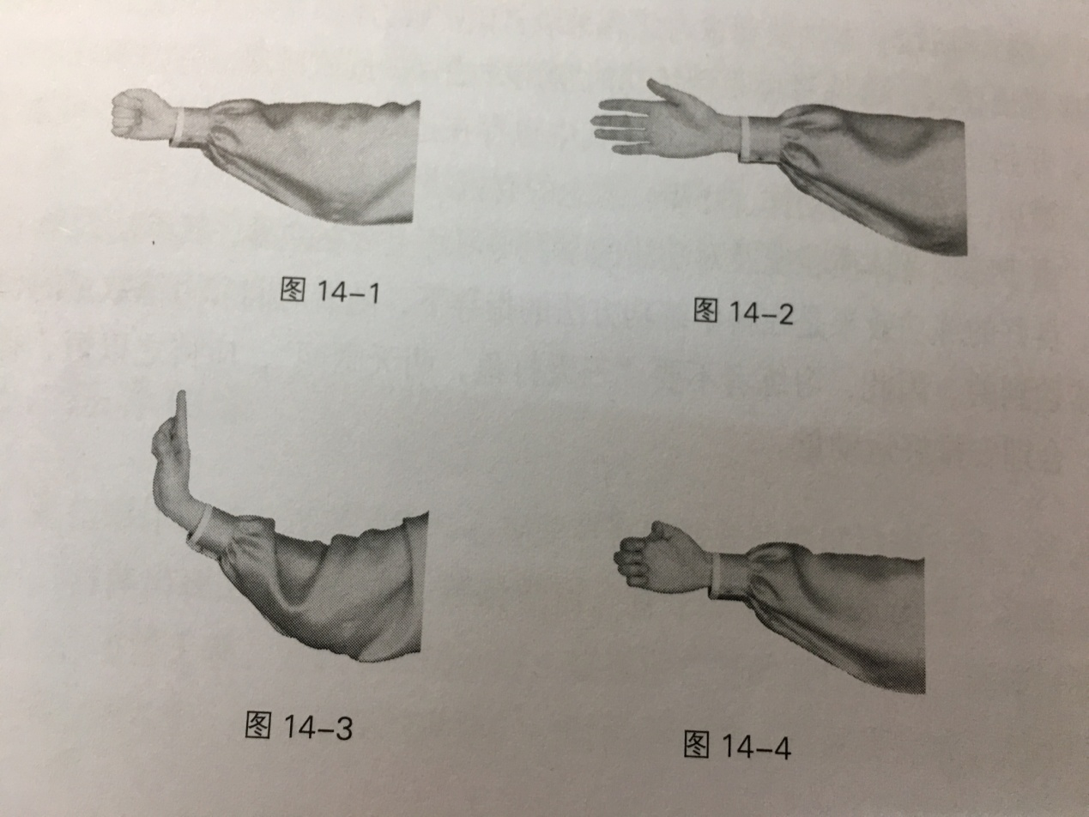

(2) Basic stance

Horse stance

Standing with two feet separated, the distance between two feet is about 2-3 times of one's feet size, bend knees to a half squatting position with thigh slightly higher than horizon.

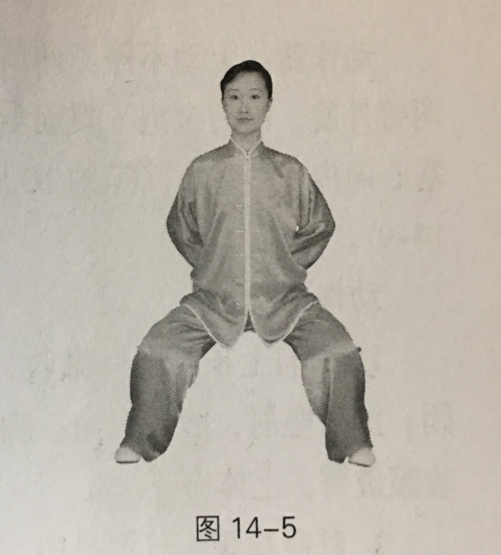

2. Movement diagram

**Preparing form**

Move 1: Stand with two feet together; the arms are naturally inclined to the body side; Keep body right and straight and look forward.

Move 2: With waist relaxed and hips taken in, move the weight onto the right leg; Set apart two feet by moving left foot half step left with tiptoes pointing forward, the distance of feet is the same as shoulders. Look forward.

Move 3: Turn two arms inward, raise two arms up at the both sides of body, the same height as hips with palms backward; look forward.

Move 4: Keep upper body motionless. Bend knee joints of two legs slightly; At the same time, Turn two arms outward and close palms together to front of the abdomen in a circular arc, the same height as umbilicus, with palms inward, the finger distance between two arms is about 10 cm; look forward.

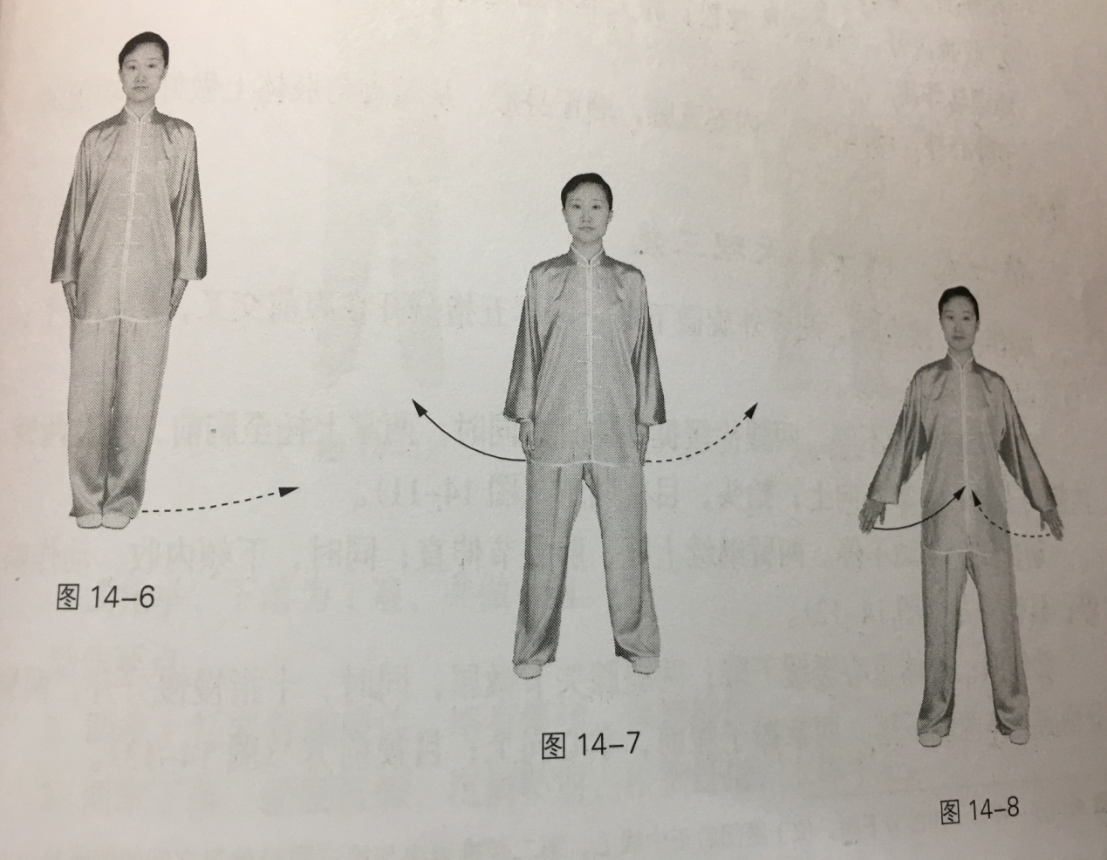

Key Points:

1. Turn head up, draw jaw back a little and make tongue touch the upper palate with lips lightly closed; Sink shoulders and lower elbows; keep upper body right and straight with chest and abdomen relaxed, hips taken in.

2. Slowly Breathe into belly for 6~9 times.

Common Faults:

1. When lowering two palms to front of the abdomen in a circular arc, turn thumb upward and the remaining four fingers tilted toward the ground.

2. Separate two feet into a shape “V” with back arch and knees down.

Correct Methods:

1. Sink shoulders and lower elbows with fingertips facing each other, keep thumb flat.

2. Make Ming men acupoint relax with waist relaxed and hips taken in; Stand with two feet parallel to each other and knee joints do not go beyond the toes.

Effects and Functions:

Regulate breath and reach a quiet and tranquil mental state, keep five internal organs (heart, liver, spleen, lungs and kidneys) normally working, adjust body to a ready position to prepare for the exercise both mentally and physically.

**First Form**

**Hold the hands high with palms upward to regulate three Jiao** (1. heart and lungs, 2.spleen and stomach, 3. liver and kidneys )

Move 1: Turn two arms outward and slightly lay them down; spread five fingers and cross them in front of the abdomen with palms upward. Look forward.

Move 2: Keep upper body motionless. Stretch two legs slowly and straighten them; At the same time, raise two palms up to the front of chest, and turn two arms inward then raise them up with palms upward; Look up, look at two palms.

Move 3: Keep upper body motionless, keep two arms raise up with elbow joints straight. At the same time, draw jaw back and keep the motion for a little while; look forward.

Move 4: Descend the weight slowly and bend knee joints of two legs slightly; at the same time, lower two arms at the both sides of body with ten fingers slowly separated. Place two palms in the front of abdomen with palms upward. Look forward.

Move 3 and Move 4 is one round of exercise. Do it six times.

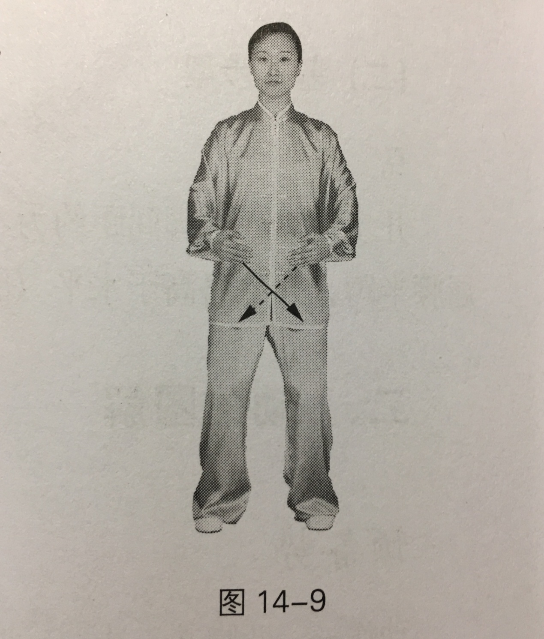

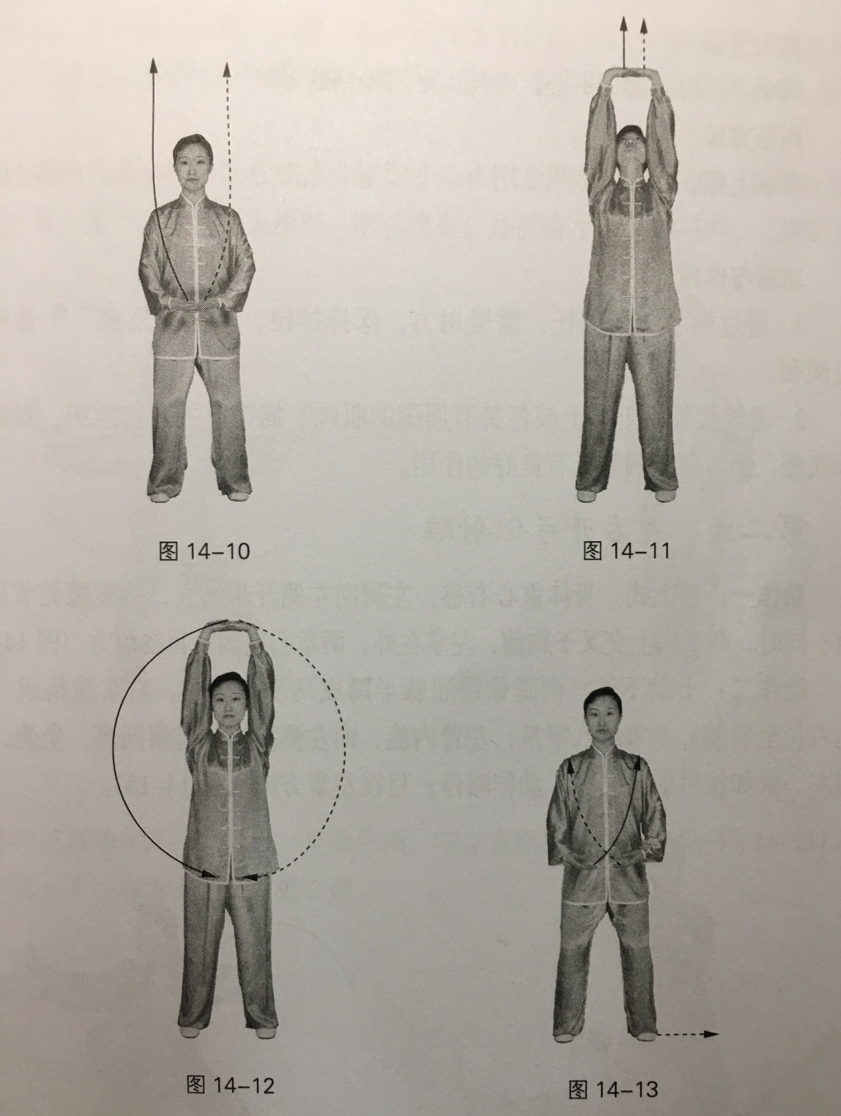

Key Points:

1. Expand breast and stretch body when raising two palms up and with a slight pause, keep the stretch for a while.

2. Lay two palms down with waist relaxed and hips taken in; sink shoulders and lower elbows, loose wrists and fingers, keep upper body right and straight.

Common Faults:

Not being able to raise head up fully when raising two palms up, head doesn’t rise up highly with loosing as well.

Correct Methods:

Expand breast and stretch body with two palms raising up. Firstly keep jaw upward, then continue to make jaw draw back in the pace of two palms and feel like power reaching heel of palms.

Effects and Functions:

1. By raising two hands up and apply the force slowly to maintain the pull, make “three Jiao” work unobstructedly to regulate and harmonize Qi and blood.
2. By lengthening the body, muscles around all joints of upper limbs, ligaments and joint soft tissues, it has a good effect on prevention and treatment of shoulder diseases and prevention of cervical spondylosis.

**Second Form**

**Bow from left to right as shooting the condor**

Move 1: Move the weight on the right. Set apart two feet by moving left foot half step left with two knee joints straightening naturally. At the same time, cross two palms in front of chest with two palms facing inward while left palm folding on right palm; Look forward.

Move 2: Keep upper body motionless, bend knee joints of two legs slowly into a horse stance; At the same time, bend fingers of right palm into "claw", pull it from the right to the front of shoulder; Made left palm into a “L” shape, turn left arm inward and push it to the left, the same height as shoulder. Lower wrist, turn palms toward the left, like a posture of bow and arrow, keep the motion for a little while; Look at the left palm.

Move 3: Move the weight on the right. At the same time, spread five fingers of the right hand into palm and draw an arc upward and right, the position of hand is the same height as shoulder with fingertips pointing upward and palm tilting forward; spread five fingers of left hand into palm with the palm tilting backward. Look at the right palm.

Move 4: Keep upper body motionless. Continue to move the weight on the right. Move Left foot inside and stand with two feet together; At the same time, lower two palms at the both sides of body and hold them in front of abdomen with fingertips facing each other, palms upward; Look forward.

Move 5 to Move 8: Same as Move 1 to Move 4, reverse left and right.

Move 1 and move 5 is one round of exercise. Do it three times.

For the last movement in the third time, continue to move the weight on the left; move right foot inside and stand with two feet apart, the distance of feet is the same as shoulders and knee joins slightly bent; At the same time, lower two palms lay down at the both sides of body and place them in front of the abdomen with fingertips pointing toward fingertips, palms upward; Look forward.

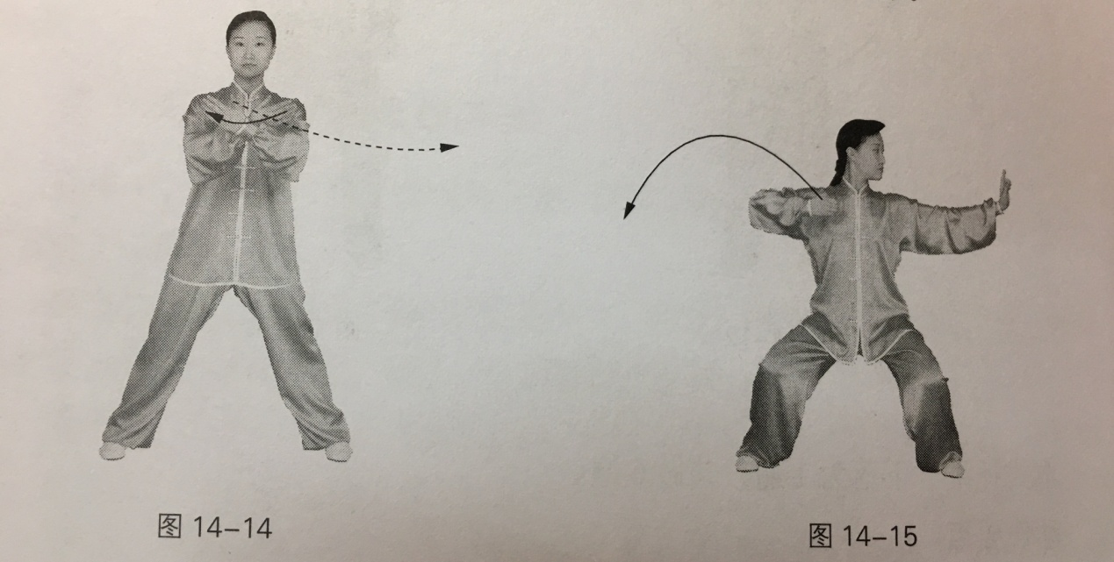

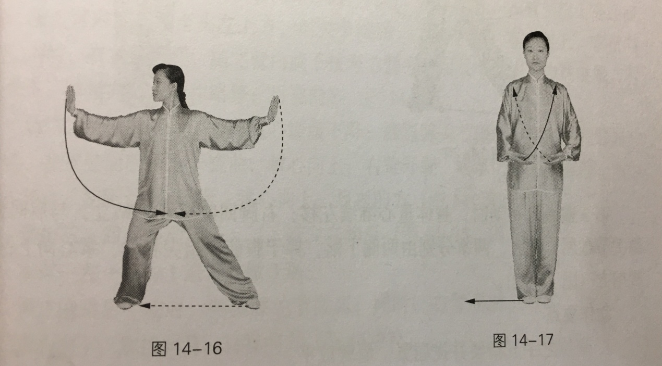

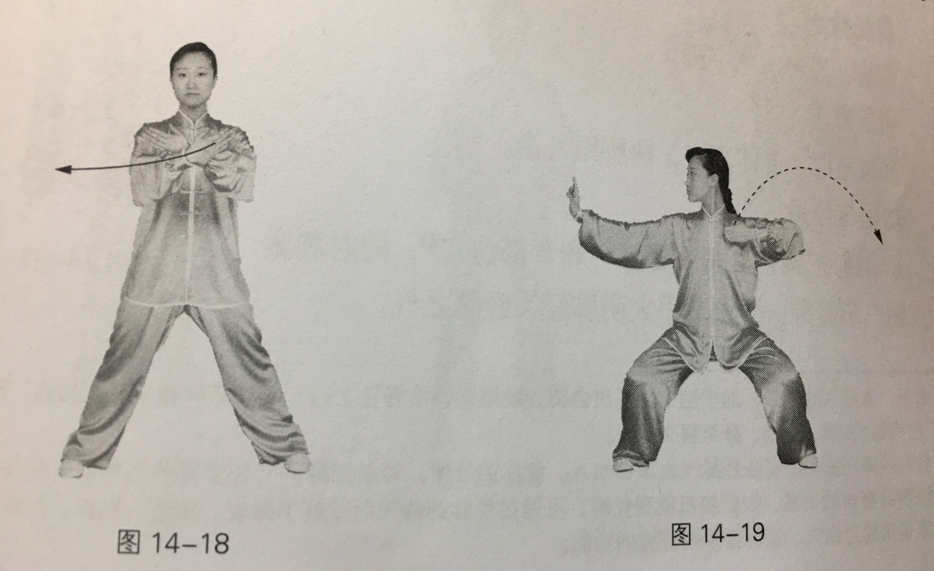

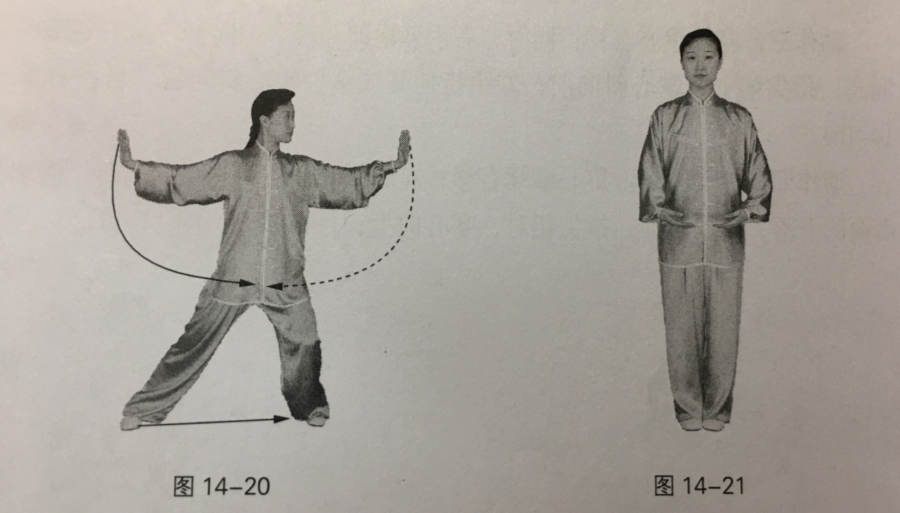

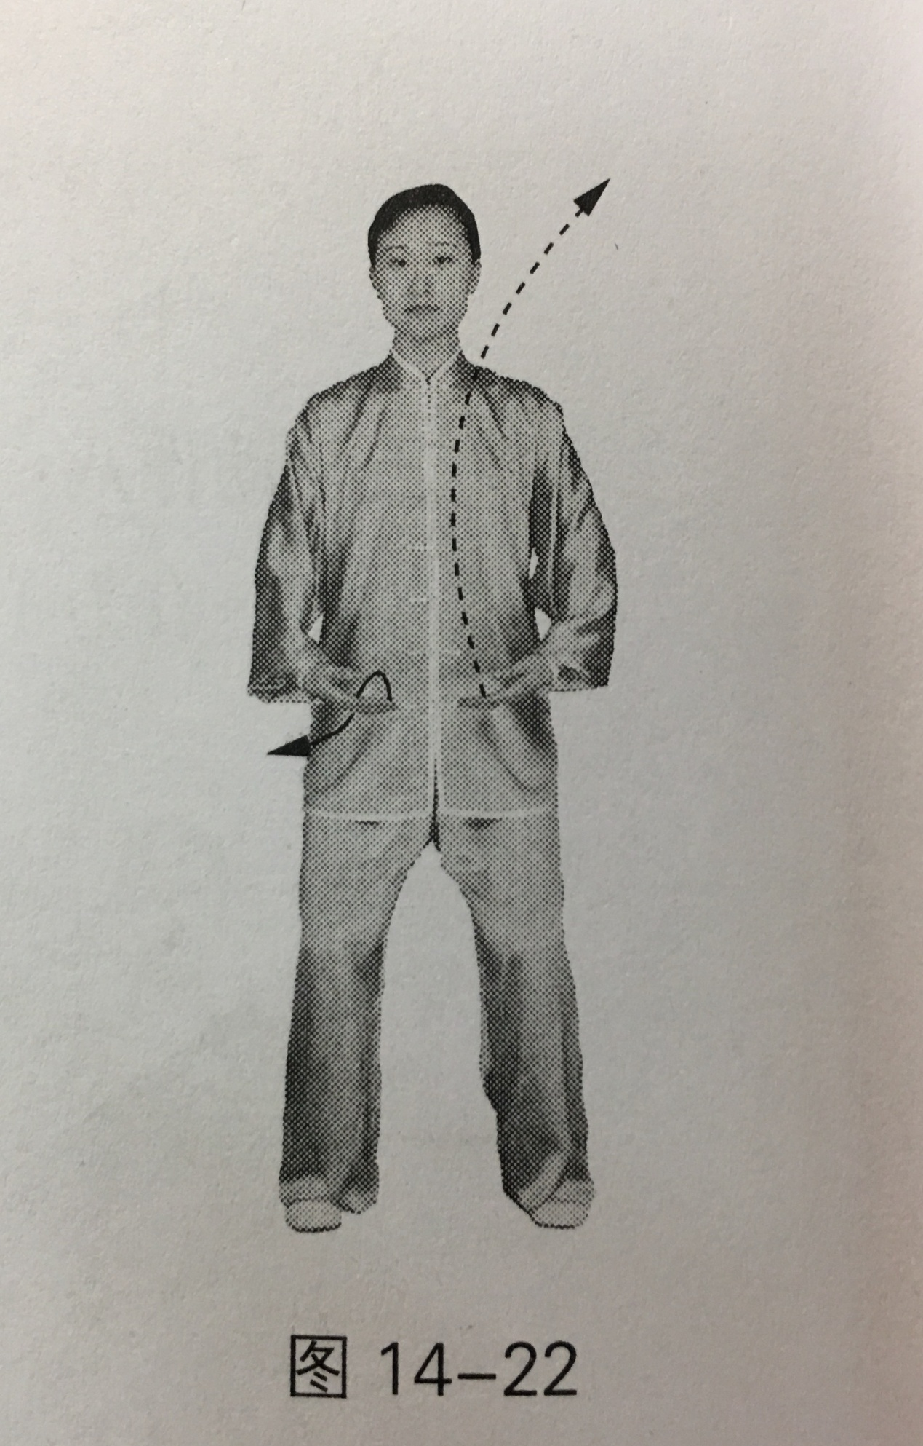

Key Points:

1. Bend five fingers and close them together while lay shoulders and arm flat.

2. Sink shoulders and lower elbows when extending the palm into a shape “L”, bend the wrists with fingers upward and with a hollow and a relaxed center of palm.

3. The elderly or the infirm can adjust the height of the horse stance.

Common Faults:

Separate two feet into a shape “V” with shoulder lifting and back arching.

Correct Methods:

Sink shoulders and lower elbows, keep upper body upright with two heels turning outward in strength.

Effects and Functions:

1. Relax shoulders and expand chest to stimulate the governor's veins and Yu acupoint on the back; At the same time, stimulate the three Yin three Yang meridian on the hand , can adjust Taiyin lung meridian on the hand and other meridians.

2. Effectively develop lower limb muscle strength and improve balance and coordination ability; at the same time, increase the strength of the forearm and hand muscles to improve the flexibility of wrist joints and knuckles.

3. Good for correcting bad posture, such as hump and turning shoulder much inward, effectively prevent shoulder and neck diseases.

**Third Form**

**Regulate spleen and stomach with one palm lifted up**

Move 1: Stretch two legs slowly and straighten them; at the same time, raise left arm up, turn left arm upward through face then turn left palm inward and lift it above the left side of head, bend elbow joint slightly and feel like power reaching heel of palms with palm upward and fingers pointing to the right. At the same time, slightly raise right palm up, then turn the arm inward lower it to the side of right hip, bend elbow joint slightly and feel like power reaching heel of palms with palm downward and fingers pointing forward, keep the motion for a little while. Look forward.

Move 2: Descend the weight slowly with waist relaxed and hips taken in; bend knee joints of two legs slightly; at the same time, turn left arm outward with elbow bending. Lower left palm in front of the abdomen through face with palm upward; turn right arm outward then turn right palm upward in front of the abdomen, with fingertips facing each other, the distance is about 10 cm with palm upward; Look forward.

Move 3、4: Same as Move 1 and 2, reverse left and right. Move 1 and move 4 is one round of exercise. Do it three times.

For the last movement in the third time, bend knee joints of two legs slightly; At the same time, bend right arm and lower right palm on the side of right hip with palm downward and fingers forward; Look forward.

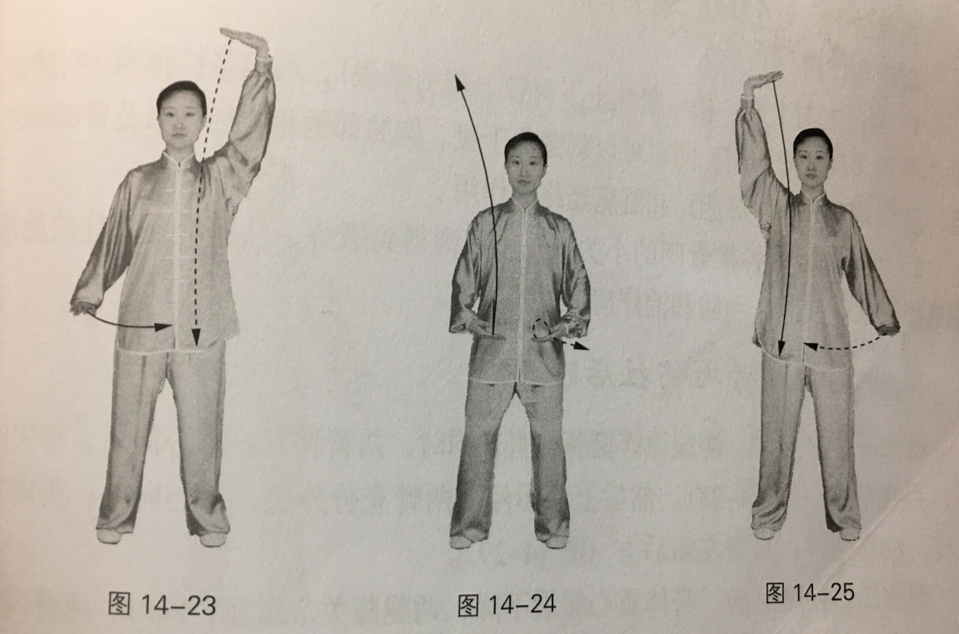

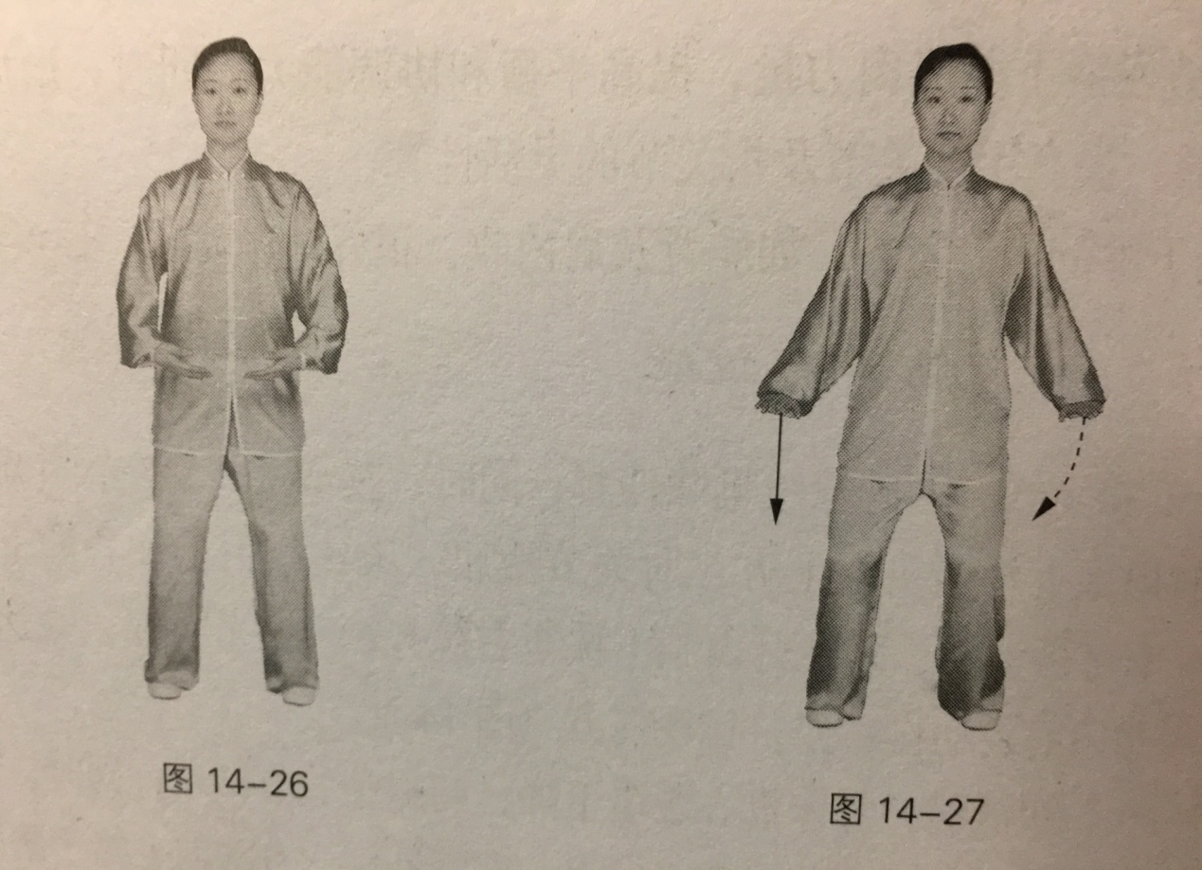

Key Points:

Raising up and pressing down palms and feel like power reaching heel of palms, expand breast and stretch body, stretch backbone out.

Common Faults:

Fingers pointing toward wrong direction, not being able to bend elbow fully, not being able to stretched the upper body fully.

Correct Methods:

Lay two palms flat and feel like power reaching heel of palms, bend elbow joints slightly and pull them.

Effects and Functions:

1. With a loose and a tight mutually pull on the left and right upper limb (static stretch), it can pull the abdominal cavity and massage the spleen and stomach. At the same time, it can stimulate the related meridians on in the abdomen and chest and Yu acupoint on the back, etc, achieving the function of regulating the spleen and stomach (hepatobiliary) and viscera meridian.

2. The small joints and small muscles between the vertebrae of the spine can be exercised to enhance the flexibility and stability of the spine, which is conducive to the prevention and treatment of shoulder and neck diseases.

**Fourth Form**

**Sickness, stress and diseases, throw them away**

Move 1: Stretch two legs slowly and straighten them; at the same time, straighten two arms with palms backward and fingertips downward, looking forward. Keep upper body motionless, turn two arms outward fully with palms outward; turn head to the left back and keep the motion for a little while; Look at left tilting backward.

Move 2: Descend the weight slowly with waist relaxed and hips taken in, bend knee joints of two legs slightly; At the same time, turn two arms inward and press them on the sides of hips with palms downward and fingertips forward. Look forward.

Move 3: same as Move 1, reverse left and right.

Move 4: same as Move 2.

Move 1 and move 4 is one round of exercise. Do it three times.

For the last movement in the third time, bend knee joints of two legs slightly. At the same time, place two palms in front of the abdomen with fingertips facing each other and fingers upward; look forward.

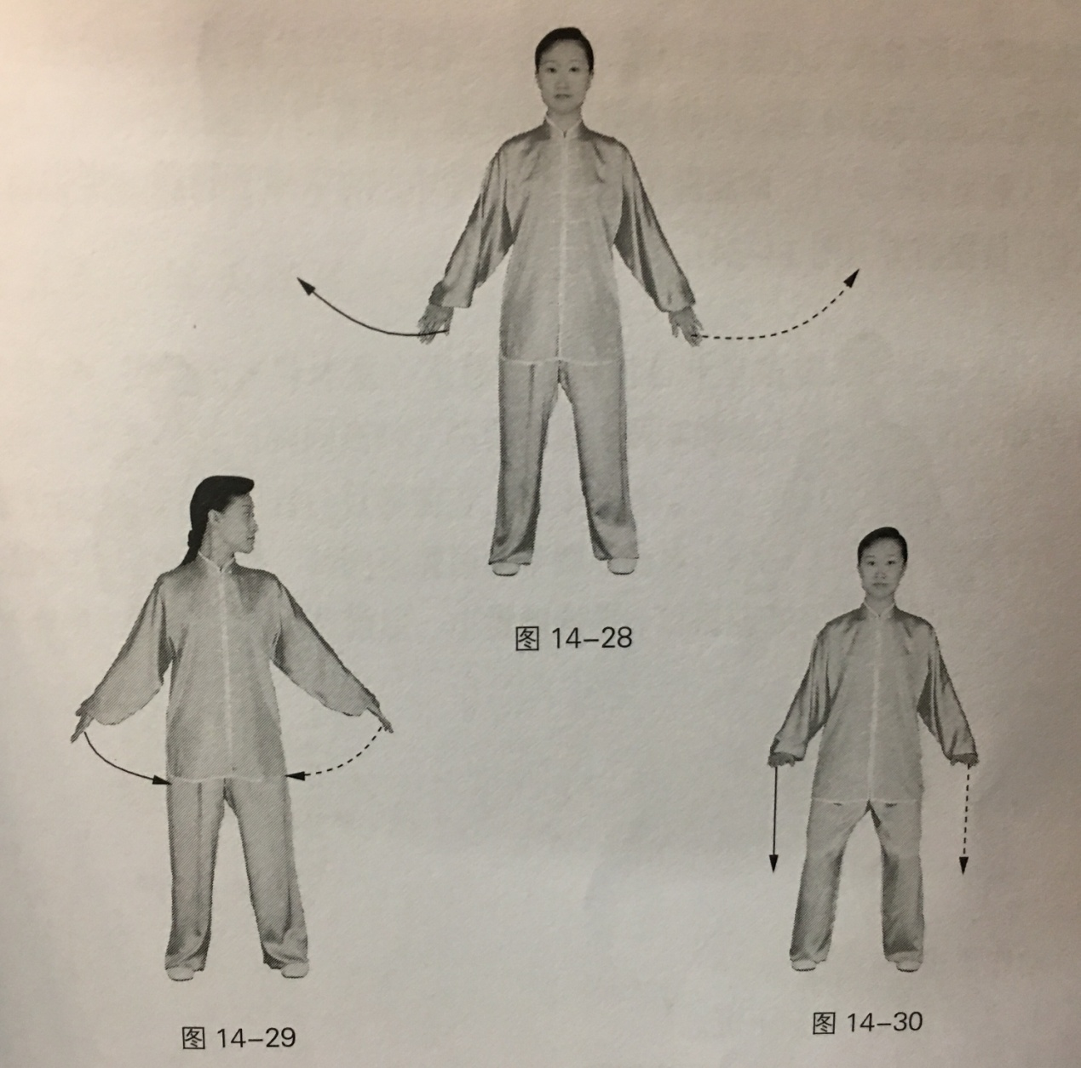

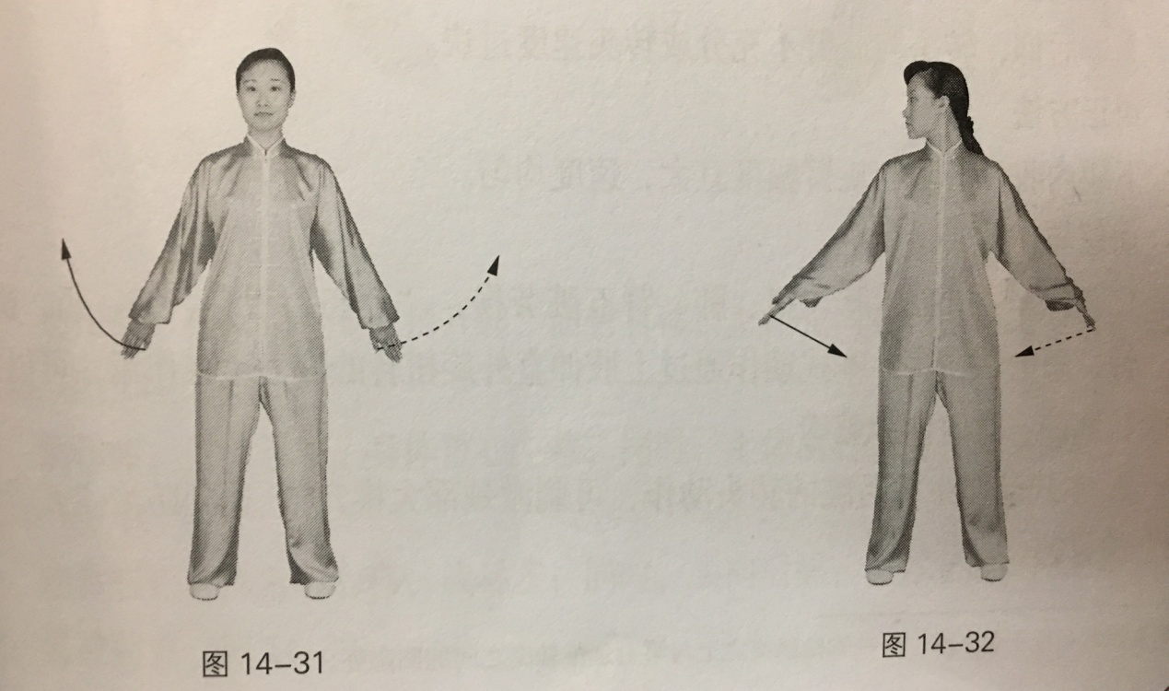

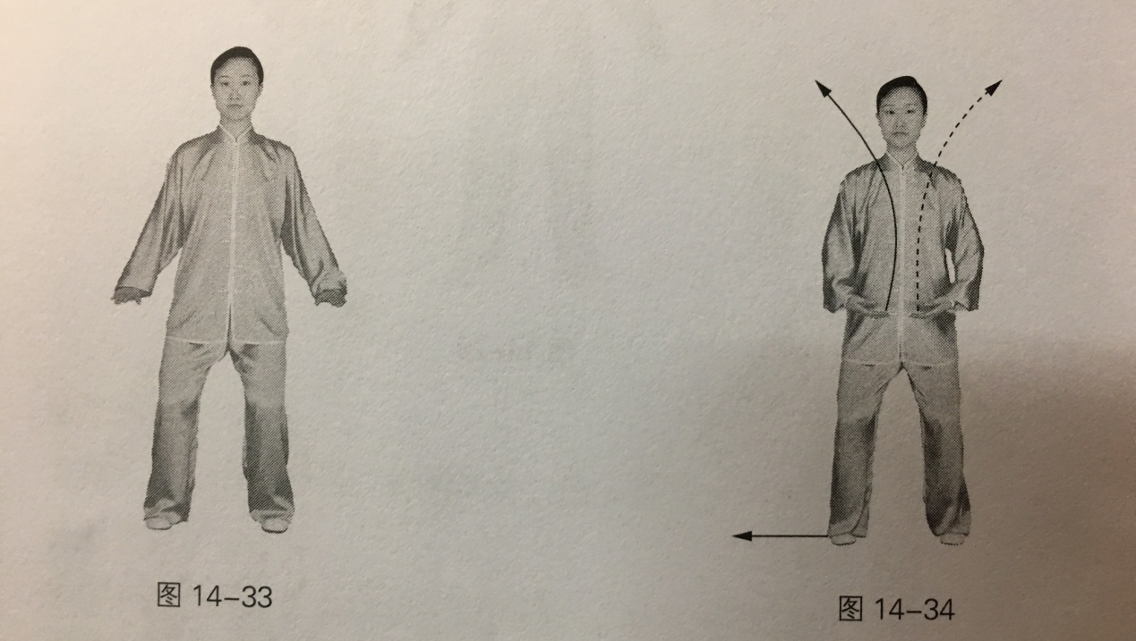

Key Points:

1. Turn head up and turn shoulders down.

2. Turn the head without turning the body, rotate the arms with two shoulders expanded toward back.

Common Faults:

Turn upper body backward, not being able to turn head and rotate arm fully or turn head too fast.

Correct Methods:

Draw jaw back, turn head and rotate arm fully with average speed.

Effects and Functions:

1. "Exhaustion of five organs" refers to strains on heart, liver, spleen, lungs, and kidneys; "Seven damages" refers to joy, anger, sadness, worry, fear, panic, thought, and emotions. This type of movement can stretch the thoracic cavity and abdominal cavity with the static stretching effect of the external rotation of the upper limbs.

2. Turning head backward in this type of movement can stimulate Dazhui cervical vertebrae and achieve the purpose of preventing “five injuries and seven injuries”.

3. It can increase the contraction force of the muscles around the neck and shoulder joints, increase the amplitude of neck movement, activate the eye muscles, prevent eye muscle fatigue and shoulder, neck and back diseases. At the same time, improving blood circulation in the neck and brain, helping relieve fatigue in the central nervous system.

**Fifth Form**

**Swing the head and lower the body to relive Xin Huo** (Yang diseases)

Move 1: Move the weight on the left; stand with two feet apart by moving right foot half step right, Stretch two legs slowly and straighten them; at the same time, raise two palms up to the front of chest. Turn two arms inward and continue to raise two palms above the head, bend elbow joints slightly bent with palms upward and fingertips facing each other; Look forward.

Move 2: Keep upper body motionless. Bend knees of two legs slowly into a horse stance; At the same time, lower two arms fall at the both sides of body and place two palms on the knee joints, bend elbow joints slightly with the small finger pointing side forward. Look forward.

Move 3: Ascend the weight slowly slightly and then move it to the right; Tilt the upper body and then bend; Look at the right leg.

Move 4: Keep upper body motionless. Move the weight to the left. At the same time, turn the upper body to the front and left from right; look at the right leg.

Move 5: Move the weight to the right and stand in horse stance; at the same time, turn head backward while straightening the upper body with jaw drawn back a little; Look forward.

Move 6 to Move 8: same as Move 3 to Move 5, reverse left and right.

Move 1 and move 8 is one round of exercise. Do it three times.

At the end of the 3rd round, move the weight to the left, move right foot inside and stand with two feet apart, the distance of feet is the same as shoulders. At the same time, turn two hands outward and raise them up at the both sides of body with palms facing toward palms; look forward. Then Descend the weight slowly with waist relaxed and hips taken in; bend knee joints of two legs slightly. At the same time, bend the elbows and lower two palms to front of the abdomen with palms downward and fingertips pointing toward fingertips; look forward.

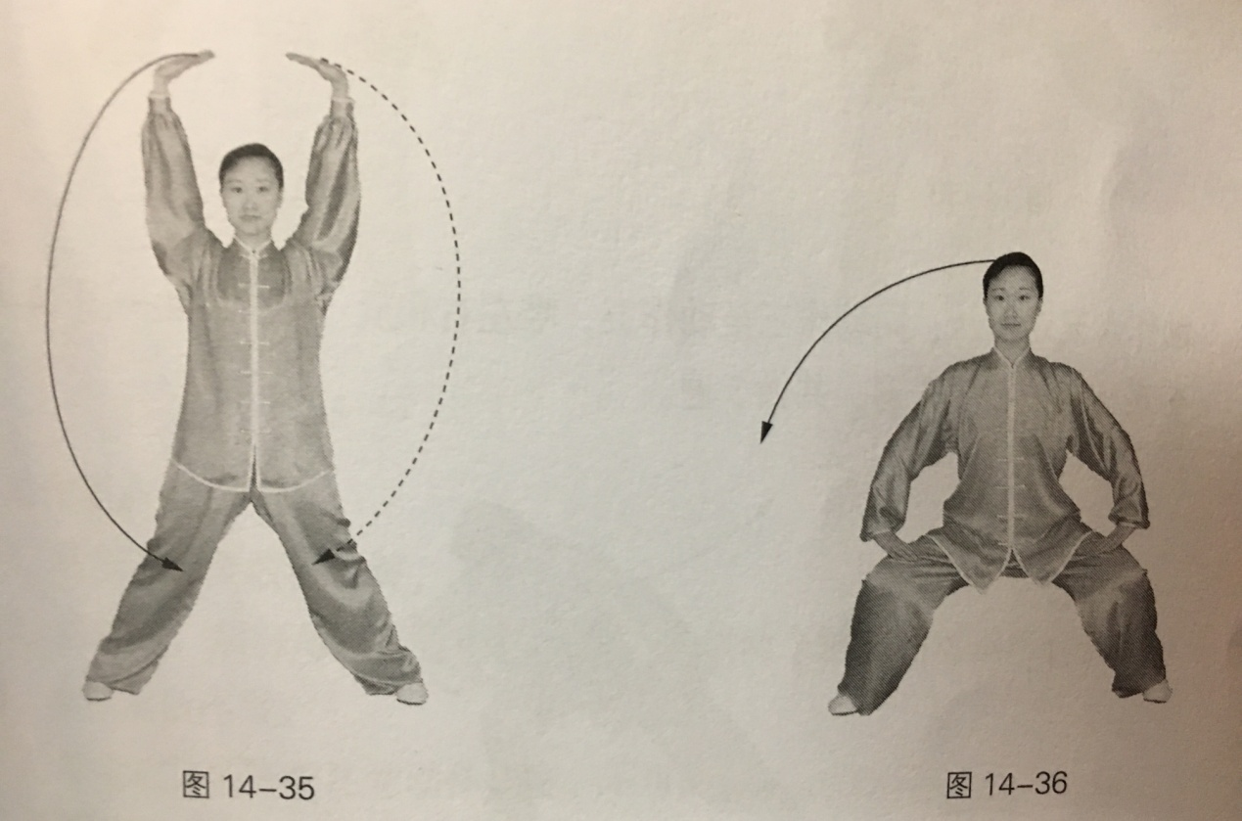

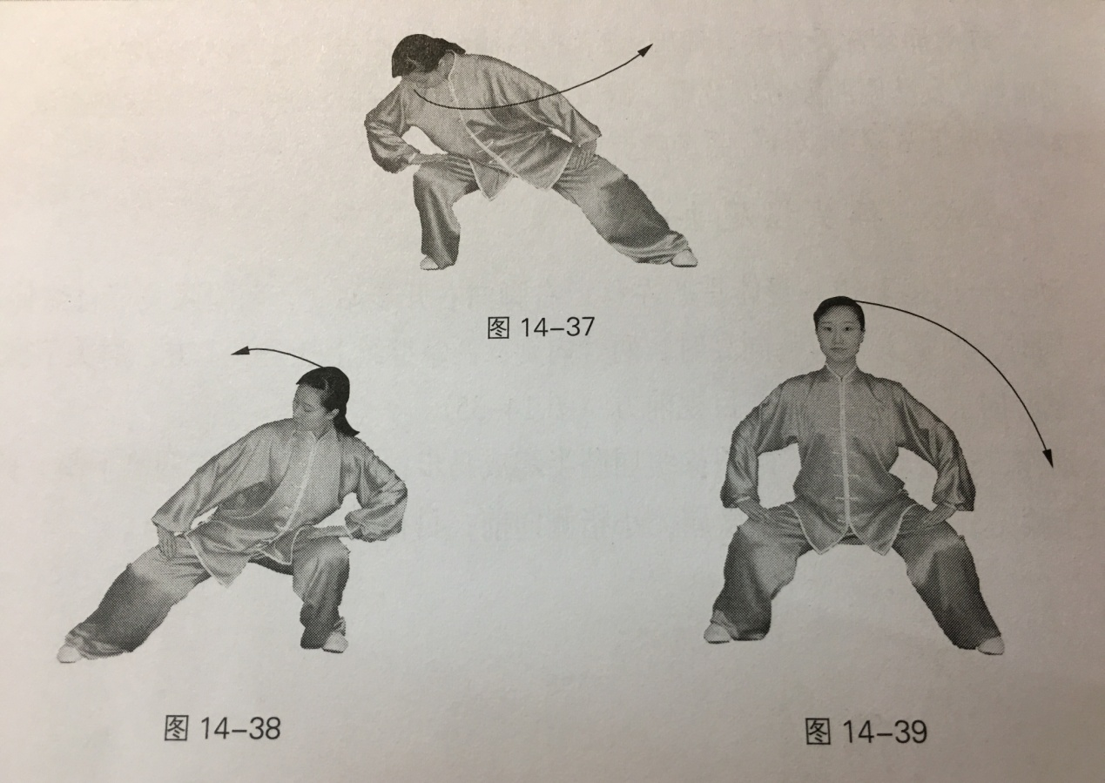

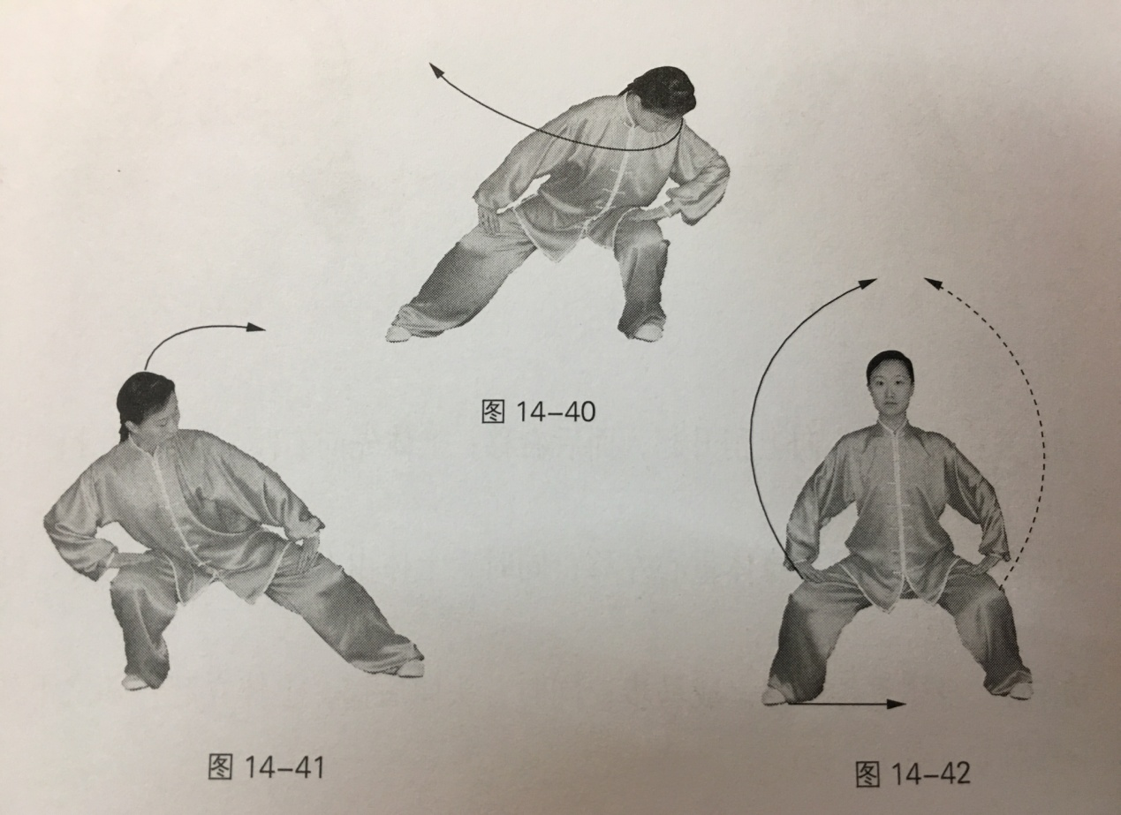

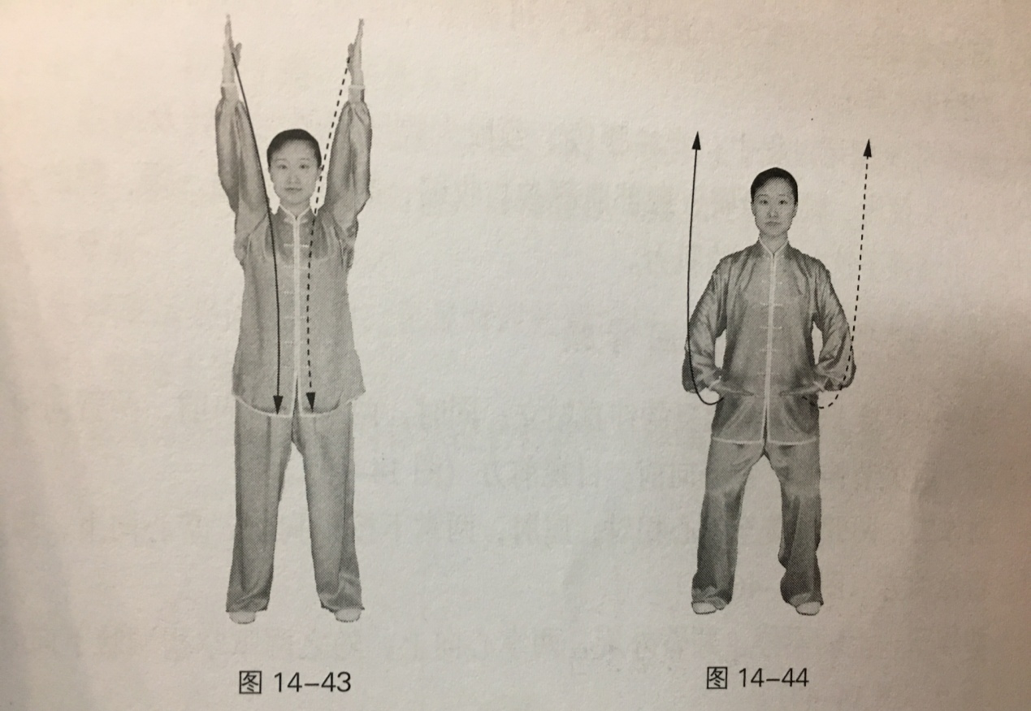

Key Points:

1. Squat into horse stance with waist relaxed and hips taken in and lift hip and keep upper body right and straight.

2. When shaking head, stretch out neck and Weilü（the end of coccyx） like two shafts in relative operation, with slow speed and coherent and continuous movement.

3. The elderly or the infirm should ensure the movement range within one's ability.

Common Faults:

1. Shaking head with stiff neck and not exercise Weilü（the end of coccyx） enough or flexibly.

2. Leaning forward too much causes the whole upper body to shake.

Correct Methods:

1. Don’t draw jaw back or raise jaw up when tilt and bend the upper body and make muscles of the cervical spine relax and stretch.

2. To increase shaking range of Weilü（the end of coccyx）, move the upper body to the left and move Weilü（the end of coccyx） of to the right, move the upper body forward and move Weilü（the end of coccyx） backward like a "circle" with head not lower than the horizontal, so that Weilü（the end of coccyx） and neck could be stretched to increase shaking range.

Effects and Functions:

1. Xin Huo (Yang diseases), is the pathogenesis of Yang heat. By squatting and shaking the rump, it can stimulate the spine, Du Channel（Governor Vessel）, etc. By shaking head, it can stimulate large vertebral cavity, so as to disperse meridian collateral and let off heat, which can help relive Xin Huo (Yang diseases).

2. When shaking head and shaking rump, make lumbar spine and neck bend tilting, rotate and swing with large degree, leading muscle groups of head& neck, waist& abdomen and hip& thign along the spine participate in the contract, not only increase flexibility of neck joints, waist and hip flexibility, but also enhance the muscle strength of these body parts.

**Sixth Form**

**Bend with Two hands put on feet good for kidneys & waist**

Move 1: Stand with two legs straightening; at the same time, turn fingertips of two arms forward and raise two arms up with elbows joints straightening and palms forward; look forward.

Move 2: Turn two arms outward with palms pointing toward palms, bend elbows and lower two palms to front of the chest with palms downward and fingertips facing each other; Look forward.

Move 3: Keep upper body motionless. Turn two arms outward with two palms upward, then turn two palms backward then put them out along the axilla; look forward.

Move 4: Turn two palms inward and lower them to the buttock along two sides of the spine; Then turn the upper body forward and continue to lower two hands above feet along both sides of feet; Look forward.

Move 5: Turn two palms forward along the horizon, then with the arm to drive the upper body to straight up, straighten two arms and lift them with palms forward; look forward.

Move 1 and move 5 is one round of exercise. Do it six times.

At the end of the 6th round, descend the weight slowly with waist relaxed and hips taken in; bend knee joints of two legs slightly; At the same time, turn two palms forward and lower them to front of the abdomen with palms downward and fingertips forward; look forward.

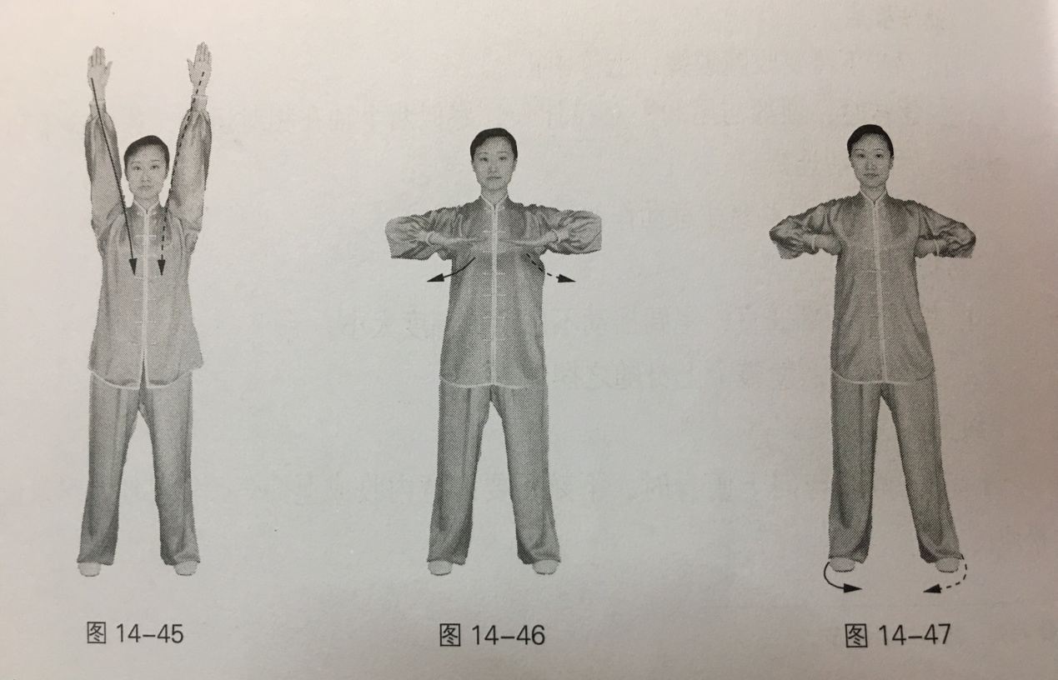

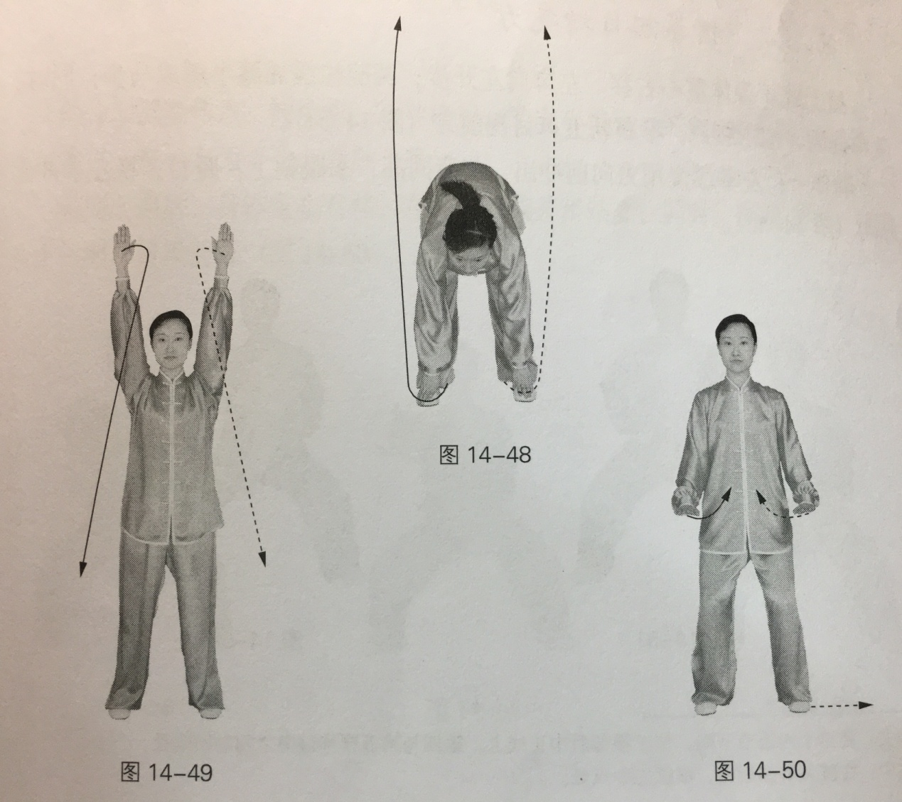

Key Points:

1. Turn two palms backward then put them out along the axilla with proper strength, sink shoulders with waist relaxed when lowering two palms above the foot. The arms lift up to make the upper body straight up with two knees upright.

2. The elderly or infirm can adjust the amplititude of movements according to their physical condition.

Common Faults:

1. Turn head down while putting out two palms along the axilla with knee joints bending.

2. When get up, firstly get up and then hold your arms up.

Correct Methods:

1. Lift your hands when moving down and straighten your knees joints.

2. Rise body with strength of arms.

Effects and Functions:

1. It can be used to stimulate the spine, Du Channel（Governor Vessel）and Ming men acupoint, Yang guan acupoint and Wei zhong acupoint and so on, which can help prevent the chronic diseases of the genitourinary system and achieve the function of strengthening the kidney.

2. It can effectively develop strength and the extension of spinal muscles in both front and back body trunk with spine greatly forward bent, at the same time, it's good for stretch&pull and massage of the kidney, adrenal, ureter and other organs on the waist, improving and stimulating functions of those body parts.

**Seventh Form**

**Clench fists for powerful strength**

Move the weight to the right and set apart two feet by moving left foot half step left. Bend knees of two legs slightly and squat into horse stance; at the same time, clench two fists and place them on both sides of waist with fist eyes upward; look forward.

Move 1: Put out left fist and punch it forward with strength slowly the position of fist is the same height as shoulder with fist eyes upward; look at the direction of left hand putting out.

Move 2: Turn left arm inward and turn left fist into palm with the thumb parallel to horizon; look at left palm. Turn left arm outward with elbow slightly bending; at the same time, rotate left palm with a half arc to the left, turn left arm upward then clench it. Look at left fist.

Move 3: Bend elbow and turn left fist inside to the waist with fist eye upward; look forward.

Move 4 to Move 6: Same as Move 1 to Move 3, reverse left and right.

Move 1 and move 6 is one round of exercise. Do it three times.

At the end of the 3rd round, Move the weight to the right, Move left foot inside and stand with two feet together; at the same time, turn two fists into palms and place them naturally to both sides of body; look forward.

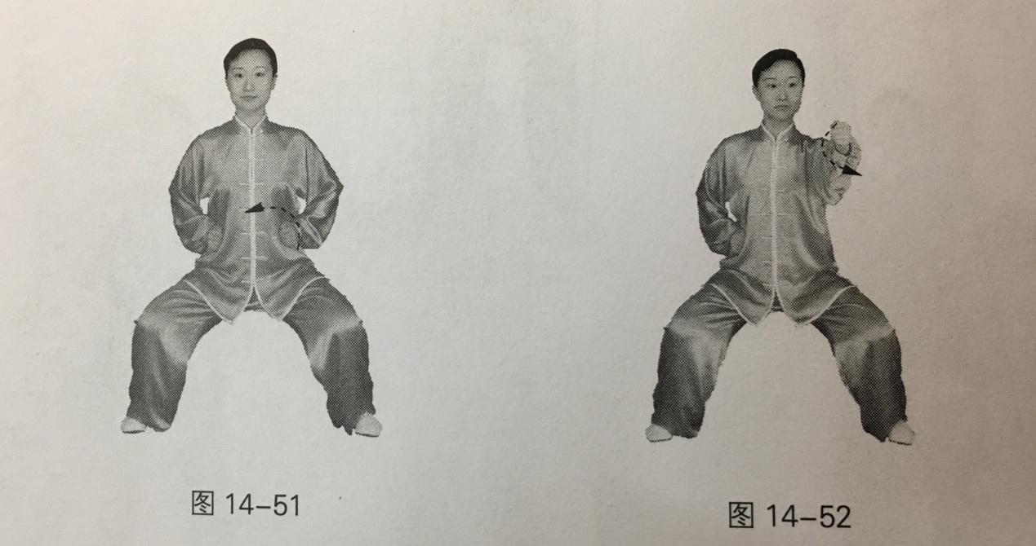

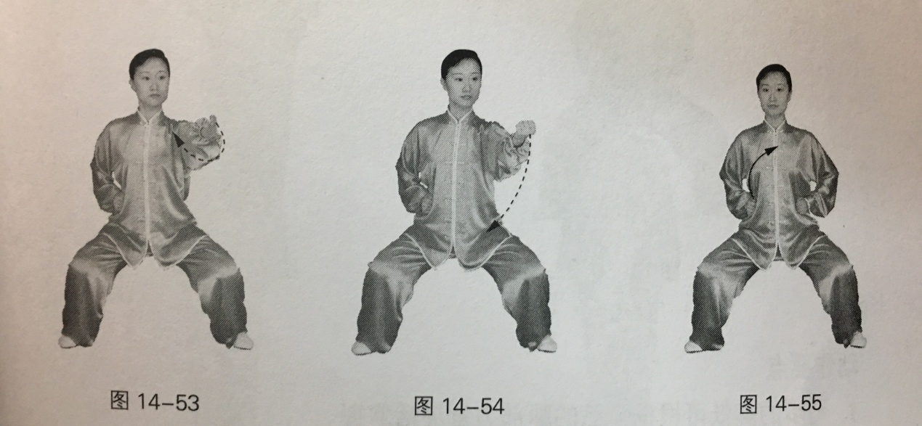

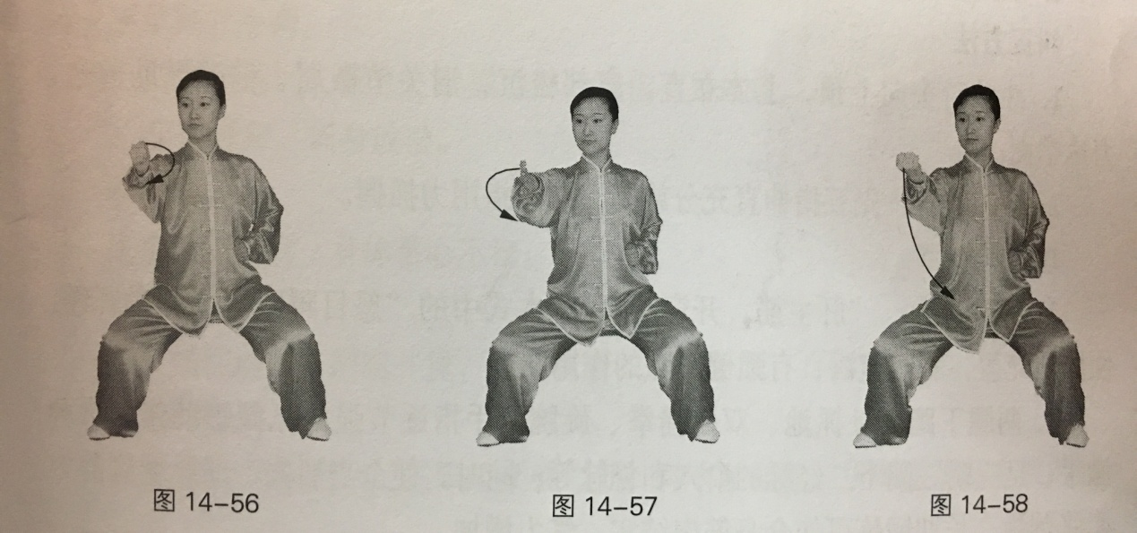

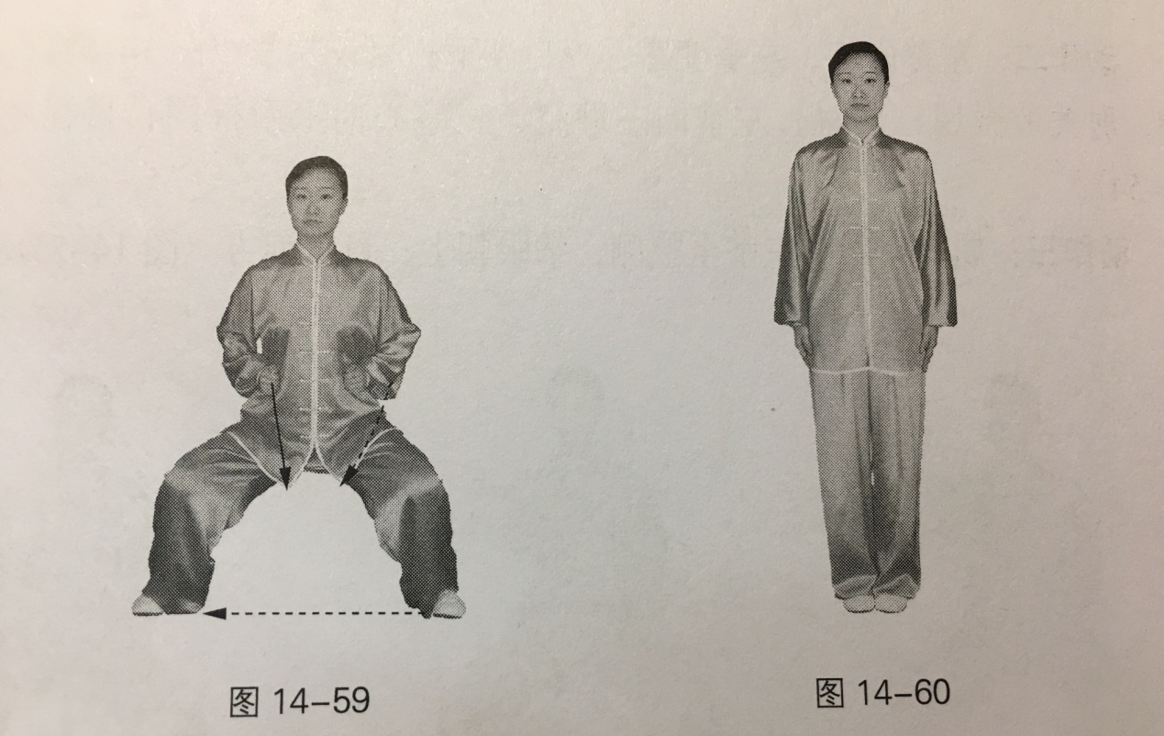

Key Points:

1. Adjust the height of the horse stance flexibly according to the strength of legs.

2. When punching, look forward in anger, eyes follow the movements of fists, at the same time, twist waist and relax shoulders with toes gripping the ground and feel like power reaching the fists; rotate wrists when move fists inside with five fingers clenching firmly.

Common Faults:

1. Lean the upper body forward when punching with shoulders rising and elbows lifting.

2. Don’t rotate wrists enough when turning fists inside because of the weak clenching.

Correct Methods:

1. Rises head up when punching and keep the upper body upright and straight, relax shoulders with elbow joints slightly bending and move forearms forward along the ribs and feel like power reaching the fists.

2. When move fists inside, firstly straighten five fingers and rotate wrists fully then bend fingers to clench fists firmly.

Effects and Functions:

1. Traditional Chinese medicine believes that "liver takes charge of tendon which is good for eyes". The movement "look forward in anger" can stimulate liver meridians, making liver blood flowing and liver work effectively, which is conducive to make tendon and bone strong.

2. Squat with ten toes gripping the ground, clenching two fists, rotating wrists and gradually clench and grasp with fingers and other movements, which can stimulate Yu acupoint and Du Channel of twelve meridians——Hand Three Ying and Three Yang Meridians as well as Foot Three Ying and Three Yang Meridians, etc. At the same time, the set of movement can make muscles and tendon meridians of whole body stimulated by the static stretch, such long-term exercise can make flesh and tendons strong.

**Acknowledgements**

Upon the completion of this thesis, I would like to extend my sincere gratitude to all the people who offered me support and helped me in finishing this paper. There are too many people for me to thank individually.

First of all, I am much indebted to my supervisor Shan Chen, for her illuminating and patient supervision. Her knowledge of sports, her experience in the research, and her careful, constructive comments and suggestions have been extremely valuable in helping me revise this thesis. Without her help, the completion of the present paper would not have been possible.

I would like to express my special gratitude to my good friends Min Zhang, who have offered me valuable help in the process of writing this thesis.

Finally, I would like to thank my family who always back me up with their spiritual and practical supports.